 **HC32L130 Series / HC32L136 Series 32-bit ARM® Cortex®-M0+ microcontroller**

**Data sheet**

Product Features

*  48MHz Cortex-M0+ 32-bit CPU platform
*  HC32L130/HC32L136 series with flexible power management system, ultra-low power performance
  + 0.5μA @ 3V Deep sleep mode: All clocks are off, power-on reset is active, IO state is held, IO interrupt is active, power consumption is saved in all registers, RAM and CPU data
  + 0.9μA @3V Deep Sleep Mode + RTC Work
  + 7μA @32.768kHz Low Speed operating mode: CPU and Peripherals run, run programs from flash
  + 35μA/MHz@3V@24MHz sleep mode: CPU stop, peripherals run, main clock run
  + 130μA/MHz@3V@24MHz mode of operation: CPU and Peripherals run, run programs from flash
  + 4μS Ultra Low Power wake-up time makes mode switching more flexible and efficient, with more agile system response
* 64K byte FLASH memory with erase protection
* 8K byte RAM memory with parity for enhanced system stability
* Universal I/O pins (56IO/64pin, 40IO/48pin)
  + Clock, Crystal oscillator
  + External high-speed Crystal 4MHz ~ 32MHz
  + External Low speed Crystal 32.768KHz
  + Internal high Speed Clock 4/8/16/22.12/24MHz
  + Internal Low Speed Clock 32.8 / 38.4KHz
  + PLL Clock 4MHz~48MHz
* hardware supports internal and external clock calibration and monitoring
* Timer/Counter
  + 3 个 1-Channel complementary universal 16-bit timers
  + 1 个 3-channel complementary output 16-bit timer
  + 1 个 Low power 16-bit timer
  + 3 个 High-performance 16-bit timers/counters to support PWM complementary, dead zone protection features
  + 1 个 programmable 16-bit timer PCA to support capture comparison, PWM output
  + 1 个Ultra low power pulse counter PCNT

* + 1 个 20 20-bit programmable watchdog circuit with built-in dedicated 10kHz Oscillator provides WDT count
* Communication interfaces
  + 2 -channel UART Standard communication interface
  + 2 -channel Lpuart low-power communication interface, working in deep sleep mode
  + 2-channel SPI Standard Communication interface – 2-channel I2C Standard communication interface
* Buzzer frequency generator, supporting complementary output
* Hardware Perpetual Calendar RTC module
* Hardware CRC-16/32 Module
* Hardware 32-bit divider
* AES-128 Hardware coprocessor
* RNG Random number generator
* 2 Channels DMAC
* 4*40/6*38/8*36 LCD Driver
* Unique 16-byte ID number
* 12-bit 1Msps sampled high-speed, high-precision SARADC with built-in operation to measure external weak signals
* Integrate 3 Multifunction OP amplifiers
* 2-channel voltage with integrated 6-bit DAC and programmable data input

Comparator VC

* Integrated low voltage detector with 16-order comparison level to monitor port voltage and supply voltage
* SWD Debugging Solution for full-featured debuggers
* Working conditions:-40 ~ 85℃,1.8 ~ 5.5V
* Package form: QFN32,LQFP64/48,TSSOP28

**Supported models**

|  |  |
| --- | --- |
| HC32L136K8TA | HC32L130F8UA |
| HC32L136J8TA | HC32L130E8PA |
| HC32L130J8TA |  |

Statement

* Huada Semiconductor Co., Ltd. (hereinafter referred to as Huada Semiconductor or Huada) reserves the right to modify this document without prior notice. Huada Semiconductor believes that the information provided is accurate and credible. This document information was introduced in August 2018. In the actual production design, please refer to the latest data manuals of each product and other relevant information to obtain the latest specifications of the company's products.

* Huada Semiconductor has intellectual property rights, including copyright, in this manual and is protected by law. No unit or individual may reproduce, modify, transcribe or disseminate this manual in any way or for any reason without the prior written permission of the company. The company shall not be liable for any errors in the contents of this document.

* Huada Semiconductor shall not be liable for any infringement of the patents, copyrights and other intellectual property rights of third parties arising from the use of the company's products specified in this document. Huada Semiconductor shall not construe the contents of this document as any express or implied license and authorization to patents, copyrights and other intellectual property rights owned by other companies or individuals.

* The circuits, software, and related information in this document are used only to illustrate the operation and application examples of semiconductor products. Users who apply the circuits, software and related information in this document in the design of the equipment shall be solely responsible. Huada Semiconductor is not responsible for any loss caused by the use of the above circuits, software and related information by users or others.

* In addition, Huada semiconductor products are not recommended for life-related equipment and systems. Huada Semiconductor assumes no responsibility for any loss caused by the failure of the device or system in the use of the device.

While the company is committed to improving the quality and reliability of semiconductor products, users should be aware of and agree that we are still unable to completely eliminate the possibility of product defects. In order to minimize damage to persons and property caused by the failure of the company's semiconductor products (including death), it is important for users to adopt the necessary safety measures in their design, such as security designs such as redundancy, fire prevention and failure prevention.

# Table of contents

Product Features 1

Disclaimer 2

Catalog 3

1. Introduction 4

2. Product Lineup 17

3. Pin Configuration 21

4. Pin function and module function 25

5. Block Diagram 37

6. Memory mapping 38

7. Electrical characteristics 40

7.1 Test Conditions 40

7.1.1. Minimum and maximum values 40

7.1.2. Typical values 40

7.1.3. Power supply Programme 41

7.2 Absolute Maximum Ratings 42

7.3 Operating Conditions 43

7.3.1 General operating Conditions 43

7.3.2 Working conditions at the time of power and power off 43

7.3.3 inline Reset and LVD module features 44

7.3.4 built-in reference voltage 46

7.3.5 power supply Current Characteristics 46

7.3.6 time to wake up from low power mode 50

7.3.7 external clock Source characteristics 51

7.3.8 internal clock Source Characteristics 55

7.3.9 PLL Features 56

7.3.10 Memory Features 56

7.3.11 EFT Features 56

7.3.12 Absolute maximum value of (electrical sensitivity) 57

7.3.13 I/O port features 57

7.3.14 RESETB PIN Characteristics 60

7.3.15 ADC features 60

7.3.16 VC Features 61

7.3.17 OPA Features 62

7.3.18 LCD Controller 63

8. Package Size 64

9. Version Info & Contact 69

# Brief introduction

The HC32L130/HC32L136 series is a MCU designed to extend the battery life of a portable measurement system with ultra-low power consumption and a wide voltage operating range. Integrated 12-bit 1M SPS high-precision SARADC and integrated comparator, OP, built-in high-performance PWM timer, LCD display, multi-channel UART, SPI, I2C and other rich communication peripherals, built-in AES,RNG and other information security modules, with high integration, high anti-interference, high reliability and ultra-low The characteristics of power consumption. This product kernel uses the Cortex-M0+ kernel, with the mature Keil & IAR Debugging and development software, support C language and assembly languages, assembly instructions.

Typical applications for ultra-low power MCUs

* Sensor applications, IoT applications；
* Intelligent transportation, Smart city, smart home；
* Fire probe, intelligent door lock, wireless monitoring and other intelligent sensor applications；
* A variety of portable devices for battery-powered and demanding power consumption.

**32-bit CORTEX M0+ kernel**

The arm®cortex®-m0+ processor is derived from Cortex-M0 and includes a 32-bit RISC processor with 0.95 computing power Dhrystone Mips/mhz. At the same time, a number of new designs have been added to improve debugging and tracking capabilities, reduce the number of each instruction cycle (IPC) and improve Flash access to the two-level pipeline, etc., and incorporate energy-saving and consumption reduction technologies. Cortex-M0+ Processor full support integrated Keil & IAR Debugger。

The Cortex-M0+ contains a hardware debugging circuit that supports 2-pin SWD debugging interface.

ARM Cortex-M0+ Features：

|  |  |
| --- | --- |
| Instruction Set | Thumb / Thumb-2 |
| Pipeline | 2-stage Pipeline |
| Performance efficiency | 2.46 CoreMark / MHz |
| Performance efficiency | 0.95 DMIPS / MHz in Dhrystone |
| Interrupt | 32 Quick Interrupts |
| Interrupt Priority | Configurable level 4 Interrupt priority |
| Enhanced Instructions | Single cycle 32-bit multiplier |
| Debugging | Serial-wire Debug Port, supports 4 hard interrupts (breakpoints) and 2 watch points |

**64K Byte Flash**

Built-in is a fully integrated Flash controller that eliminates the need for external high-voltage input and is programmed by a fully built-in circuit to generate high pressure. Support for ISP, IAP, ICP features.

**8K Byte RAM**

The RAM data is preserved depending on the customer's choice of a different ultra-low power mode. With its own hardware parity bit, in case the data is accidentally destroyed, when the data is read, the hardware circuit will immediately cause interrupt, to ensure the reliability of the system.

The clock system has a frequency of 4M~24MHz configurable high-precision internal clock RCH. Under Configuration 16MHz, from low power mode to working mode.

Typical wake-up time is 3uS, the frequency deviation in the full voltage range is <±2.5%, without the need for external expensive high-frequency crystals.

An external crystal vibration XTH with a frequency of 4M~32MHz.

An external crystal XTL with a frequency of 32.768KHz, which mainly provides an RTC real-time clock.

一An internal clock RCL with a frequency of 32.768/38.4KHz.

一A PLL with a frequency of 4M~48MHz output。

Working modes

1. Running mode ACTIVE:CPU runs, peripheral function module runs.
2. The hibernation mode Sleep:cpu stops running and the peripheral function module runs.
3. Deep hibernation mode Deep SLEEP:CPU stops running, high-speed clock stops, and low-power function modules run.

Hardware real-time clock RTC

The RTC (Real Time counter) is a register that supports BCD data, uses 32,768Hz to refresh its clock, enables the perpetual calendar function, and the interrupt period can be configured as a year/month/day/hour/minute/second. 24/12 Hour time mode, hardware automatically fixes leap years. With precision compensation function, the highest accuracy is 0.96ppm. Accuracy compensation can be performed using an internal temperature sensor or an external temperature sensor, with software +1/-1 adjusted year/month/day/hour/minute/sec with a minimum adjustable accuracy of 1 second.

The RTC calendar recorder used to indicate the time and date does not clear the reserved value when the MCU is reset by external factors, and is the best choice for measuring equipment instrumentation that requires a permanent, high-precision real-time clock.

The universal IO Port can provide up to 56 gpio ports, some of which are reused with analog ports. Each port is controlled by a separate control register bit and supports FAST IO. Supports edge trigger interrupts and level trigger interrupts to wake the MCU to work mode from a variety of ultra-low power modes. Support position bit, bit clear zero, position clear 0 operation. Support Push-pull CMOS push-pull output, open-drain open leakage output. Built-in pull-up resistor, drop-down resistor, with Schmidt trigger input filtering function. Output drive capability configurable, maximum support 12mA of current drive capability. 56 Universal IO can support external asynchronous interrupts.

Interrupt Controller

The cortex-m0+ processor has a built-in nested vector interrupt Controller (NVIC) that supports up to 32 interrupt request (IRQ) inputs, four interrupt priorities, can handle complex logic, and can be controlled and interrupted in real time.

32 Interrupt entry vector addresses, respectively：

|  |  |
| --- | --- |
| Interrupt Vector number | Interrupt Source |
| [0] | GPIO_PA |
| [1] | GPIO_PB |
| [2] | GPIO_PC |
| [3] | GPIO_PD |
| [4] | DMAC |
| [5] | TIM3 |
| [6] | UART0 |
| [7] | UART1 |
| [8] | LPUART0 |
| [9] | LPUART1 |
| [10] | SPI0 |
| [11] | SPI1 |
| [12] | I2C0 |
| [13] | I2C1 |
| [14] | TIM0 |
| [15] | TIM1 |
| [16] | TIM2 |
| [17] | LPTIM |
| [18] | TIM4 |
| [19] | TIM5 |
| [20] | TIM6 |
| [21] | PCA |
| [22] | WDT |
| [23] | RTC |
| [24] | ADC |
| [25] | PCNT |
| [26] | VC0 |
| [27] | VC1 |
| [28] | LVD |
| [29] | LCD |
| [30] | RAM FLASH |
| [31] | CLKTRIM |

Reset Controller

This product has 7 reset signal sources, each reset signal can let the CPU rerun, the vast majority of registers will be reset, the program counter PC will reset point to 00000000.

|  |  |
| --- | --- |
|  | Interrupt Source |
| [0] | Power off the reactivity returns-bit POR BOR |
| [1] | External Reset Pin Reset |
| [2] | WDT Reset |
| [3] | PCA Reset |
| [4] | Cortex-M0+ Lockup Hardware Reset |
| [5] | Cortex-M0+ SYSRESETREQ Software Reset |
| [6] | LVD Reset |

**DMAC**

The DMAC (Direct Memory Access Controller) function block can transmit data at high speed without CPU. Using DMAC can improve system performance.

Timer/Counter

|  |  |  |  |  |  |  |  |
| --- | --- | --- | --- | --- | --- | --- | --- |
| Type | Name | Bit width | Pre-removal frequency | Counting direction | PWM | Capture | Complementary output |
| Universal Timer | TIM0 | 16/32 | 1/2/4/8/16  32/64/256 | Up count/Down Count/Up and down Count | 2 | 2 | 1 |
| TIM1 | 16/32 | 1/2/4/8/16/  32/64/256 | Up count/Down Count/Up and down Count | 2 | 2 | 1 |
| TIM2 | 16/32 | 1/2/4/8/16/  32/64/256 | Up count/Down Count/Up and down Count | 2 | 2 | 1 |
| TIM3 | 16/32 | 1/2/4/8/16/  32/64/256 | Up count/Down Count/Up and down Count | 6 | 6 | 3 |
| Low Power timer | LPTIM | 16 | None | Count up | None | None | None |
| Programmable count Array | PCA | 16 | 2/4/8/16/32 | Count up | 5 | 5 | None |
| Advanced Timer | TIM4 | 16 | 1/2/4/8/16/ 64/256/1024 | Up count/Down Count/Up and down Count | 2 | 2 | 1 |
| TIM5 | 16 | 1/2/4/8/16/ 64/256/1024 | Up count/Down Count/Up and down Count | 2 | 2 | 1 |
| TIM6 | 16 | 1/2/4/8/16/ 64/256/1024 | Up count/Down Count/Up and down Count | 2 | 2 | 1 |

The universal timer contains four timer TIM0/1/2/3.

Universal Timer Features

* PWM independent output, complementary output
* Capture input
* Dead Zone Control
* Brake control
* Edge alignment, symmetric center alignment and Asymmetric center alignment PWM output

Orthogonal encoding counting function

Single pulse mode

* External counting function

The TIM0/1/2 function is identical. TIM0/1/2 is a synchronous timing/counter that can be used as a timing/counter for a 16-bit automatic reload function, or as a timing/counter for 32-bit non-overloaded functions. TIM0/1/2 each timer has a 2-way capture comparison function that produces 2-way PWM independent output or 1 sets of PWM complementary outputs. Has dead zone control function.

TIM3 is a multi-channel universal timer with all the functions of the TIM0/1/2 to produce 3 sets of PWM complementary outputs or 6 PWM independent outputs, up to 6 input captures. Has dead zone control function.

The low-Power timer Lptim is an asynchronous 16-bit timing/counter that can still be timed/counted by internal low-speed RC or external low-speed crystal oscillation after the system clock is turned off. Wake the system in low-power mode by interrupting.

PCA (programmable counter array programmable counter array) supports up to 5 16-bit capture/comparison modules. The timing/counter can be used as a common capture/comparison feature for clock counting/event counters. Each module of the PCA can be independently compiled

To provide input capture, output comparison or pulse width modulation. In addition the Module 4 has an additional watchdog timer mode.

Advanced Timer Advanced timer contains three timer TIM4/5/6. TIM4/5/6 is a high-performance counter with the same functionality that can be used to count different forms of clock waveforms, and 1 timers can produce complementary pair of PWM or independent 2-way PWM outputs that capture external inputs for pulse width or cycle measurements.

The basic features and features of Advanced Timer are shown in the table:

|  |  |
| --- | --- |
| Waveform mode | Sawtooth Wave, triangle wave |
| Basic Features | • recursion, decreasing counting direction |
| • Software Synchronization |
| • Hardware synchronization |
| • Caching Features |
| • Orthogonal encoding Count |
| • Universal PWM Output |
| • Protection mechanisms |
| • AOS Associated Actions |
| Interrupt type | Count Comparison match interrupts |
| Count Cycle Match Interrupt |
| Dead Zone Time error interrupt |

Ultra Low Power pulse counter **PCNT**

The pcnt Pulse counter module is used to count external pulses and support exteriors and dual (orthogonal and non-cross-encoding) pulses. It can be counted without software involvement in low-power hibernation mode：

* 16 bit counters that support overloaded features
* Single channel pulse count
* Dual channel non-intersecting pulse count
* Dual channel orthogonal pulse count, without losing code
* Add/Subtract Count overflow interrupt
* Pulse Timeout Interrupt
* 4 decoding error interruptions, non-intersecting pulse mode
* 1 direction change interrupt, orthogonal pulse mode
* multistage Pulse Width filtering
* Input Pulse polarity Configurable
* Support for low power mode counts
* Support for wake-up MCU in low power mode
* Supports arbitrary pulse along spacing not less than 1 count clock cycles

Watchdog WDT

WDT (watch Dog timer) is a configurable 20-bit timer that provides reset in the case of MCU abnormalities; built-in 10KHz Low speed clock input as counter clock. In debug mode, you can choose to pause or continue to run; You can restart WDT only if you write a specific sequence.

Universal Asynchronous Transceiver UART0~UART1

2-channel Universal Asynchronous Transceiver (Universal asynchronous Receiver/transmitter), UART0/UART1.

UART Basic Features：

* Half-duplex and full-duplex transmission
* 8/9-Bit Transfer Data length
* Hardware parity
* 1/1.5/2-Bit Stop Bit
* Four different transmission modes
* 16-Bit Baud Rate counter

Multi-machine communication hardware address recognition

* Hardware Transfer handshake
* Hardware flow control

Low Power Asynchronous Transceiver LPUART0~LPUART1

Asynchronous transceivers (Low power Universal asynchronous Receiver/transmitter) that can work in 2-way lower power mode, LPUART0/LPUART1。

Lpuart Basic Features：

* 传输时钟 SCLK（SCLK 可选择 XTL、RCL 以及 PCLK）
* 系统低功耗模式下收发数据
* 半双工和全双工传输
* 8/9-Bit 传输数据长度
* 硬件奇偶校验
* 1/1.5/2-Bit 停止位
* 四种不同传输模式
* 16-Bit 波特率计数器
* 多机通讯
* 硬件地址识别
* DMAC 硬件传输握手
* 硬件流控

同步串行接口 **SPI**

2 路同步串行接口（Serial Peripheral Interface）。

SPI 基本特性：

* 通过编程可以配置为主机或者从机
* 四线传输方式，全双工通信
* 主机模式 7 种波特率可配置
* 主机模式最大波特率为 1/2 系统时钟

从机模式最大波特率为 1/8 系统时钟

可配置的串行时钟极性和相位

* 支持中断
* 8 位数据传输，先传输高位后低位
* 支持 DMA 软件/硬件访问

**I2C** 总线

2 路 I2C，采用串行同步时钟，可实现设备之间以不同的速率传输数据。

I2C 基本特性：

* 支持主机发送/接收，从机发送/接收四种工作模式
* 支持标准(100Kbps) / 快速(400Kbps) / 高速(1Mbps) 三种工作速率
* 支持 7 位寻址功能
* 支持噪声过滤功能
* 支持广播地址
* 支持中断状态查询功能

蜂鸣器 **Buzzer**

4 个通用定时器与 1 个 低功耗定时器功能复用输出为 Buzzer 提供可编程驱动频率。该蜂鸣器端口可提供 16mA 的 sink 电流，互补输出，不需要额外的三极管。

时钟校准电路内建时钟校准电路，可以通过外部精准的晶振时钟校准内部 RC 时钟，亦可使用内部 RC 时钟去检验外部晶振时钟是否工作正常。

时钟校准基本特性：

* 校准模式
* 监测模式
* 32 位参考时钟计数器可加载初值
* 32 位待校准时钟计数器可配置溢出值
* 6 种参考时钟源

5 种待校准时钟源支持中断方式

唯一识别号 **UID**

每颗芯片出厂前具备唯一的 16 Bytes 设备标识号，包括 wafer lot 信息，以及芯片坐标信息等。UID 地

址为：0X00100E74 - 0X00100E7D。

**CRC16/32** 硬件循环冗余校验码

CRC16 符合 ISO/IEC13239 中给出的多项式 =X16 + X12 + X5 + 1

CRC32 符合 ISO/IEC13239 中给出的多项式 = x32+x26+x23+x22+x16+x12+x11+x10+x8 +x7 +x5 +x4+x2 +x+1

**32** 位硬件除法器

HDIV（Hardware Divider）是一个 32 位有/无符号整数硬件除法器。

HDIV 硬件除法器基本特性：

* 可配置有符号/无符号整数除法计算
* 32 位被除数，16 位除数
* 输出 32 位商和 32 位余数
* 除数为零警告标志位，除法运算结束标志位
* 10 个时钟周期完成一次除法运算
* 写除数寄存器触发除法运算开始
* 读商寄存器/余数寄存器时自动等待计算结束

**AES** 硬件加密

AES（The Advanced Encryption Standard）是美国国家标准技术研究所（NIST）在 2000 年 10 月 2 日正

式宣布的新的数据加密标准。AES 的分组长度固定为 128 位，而密钥长度支持 128。

**RNG** 随机数发生器

RNG 是一个真随机数发生器，用来产生随机数。

**12 Bit SARADC**

单调不失码的 12 位逐次逼近型模数转换器，在 24M ADC 时钟下工作时，采样率达到 1Msps。参考电压可选择片内精准电压（1.5v 或 2.5v）或从外部输入或电源电压。30 个输入通道，包括 24 路外部管脚输入、1 路内部温度传感器电压、1 路 1/3 电源电压、1 路内建 BGR 1.2V 电压、3 路 OPA 输出。

内建可配置的输入信号放大器以检测弱信号。

SAR ADC 基本特性：

* 12 位转换精度；
* 1M SPS 转换速度；
* 30 个输入通道，包括 24 路外部管脚输入、1 路内部温度传感器电压、1 路 1/3 AVCC 电压、1 路内建 BGR 1.2V 电压、3 路 OPA 输出；
* 4 种参考源：AVCC 电压、ExRef 引脚、内置 1.5v 参考电压、内置 2.5v 参考电压；
* ADC 的电压输入范围：0~Vref；
* 4 种转换模式：单次转换、顺序扫描连续转换、插队扫描连续转换、连续转换累加；
* 输入通道电压阈值监测；
* 软件可配置 ADC 的转换速率；
* 内置信号放大器，可转换高阻信号；
* 支持片内外设自动触发 ADC 转换，有效降低芯片功耗并提高转换的实时性。

电压比较器 **VC**

芯片管脚电压监测/比较电路。16 个可配置的正外部输入通道，11 个可配置的负外部输入通道；5 个内

部负输入通道，包括 1 路内部温度传感器电压、1 路内建 BGR 2.5V 参考电压、1 路内建 BGR 1.2V 电压、1 路 64 阶电阻分压。VC 输出可供通用定时器 TIM0/1/2/3，低功耗定时器 LPTIM 与可编程计数阵列 PCA 捕获、门控、外部计数时钟使用。可根据上升/下降边沿产生异步中断，从低功耗模式下唤醒

MCU。可配置的软件防抖功能。

低电压检测器 **LVD**

对芯片电源电压或芯片管脚电压进行检测。16 档电压监测值（1.8v ~ 3.3v）。可根据上升/下降边沿产生异步中断或复位。具有硬件迟滞电路和可配置的软件防抖功能。

LVD 基本特性：

4 路监测源，AVCC、PC13、PB08、PB07；

16 阶阈值电压，1.8V~3.3V 可选；

* 8 种触发条件，高电平、上升沿、下降沿组合；
* 2 种触发结果，复位、中断；
* 8 阶滤波配置，防止误触发；
* 具备迟滞功能，强力抗干扰。

运放 **OPA**

OPA 模块可以灵活配置，适用于简易滤波器和 Buffer 应用。内部的三个运放可以配置为反向、同向具有不同增益的组合运放，也可以使用外部电阻进行级联。

**LCD** 驱动

LCD 控制器是一款适用于单色无源液晶显示器（LCD）的数字控制器/驱动器，最多具有 8 个公用端子

（COM）和 40 个区段端子（SEG），用以驱动 160 (4x40)或 288 (8x36)个 LCD 图像元素。可以选择电容分压或电阻分压，支持内部电阻分压。内部电阻分压可以调节对比度。支持 DMA 硬件数据传输。

LCD 基本特性：

* 高度灵活的帧速率控制。
* 支持静态、1/2、1/3、1/4、1/6 和 1/8 占空比。
* 支持 1/2、1/3 偏置。
* 多达 16 个寄存器的 LCD 数据 RAM。
* 可通过软件配置 LCD 的对比度。
* 3 种驱动波形生成方式
  + 内部电阻分压、外部电阻分压，外部电容分压方式
  + 可通过软件配置内部电阻分压方式的功耗，从而匹配 LCD 面板所需的电容电荷
* 支持低功耗模式：LCD 控制器可在 Active、Sleep、DeepSleep 模式下进行显示。
* 可配置帧中断。
* 支持 LCD 闪烁功能且可配置多种闪烁频率
* 未使用的 LCD 区段和公共引脚可配置为数字或模拟功能。

嵌入式调试系统

嵌入式调试解决方案，提供全功能的实时调试器，配合标准成熟的 Keil/IAR 等调试开发软件。支持 4 个硬断点以及多个软断点。

在线编程模式支持在线编程，将 MODE（PD03）管脚接高电平即可进入 ISP 在线烧录模式。MODE 管脚接低电平进入用户模式。

高安全性

加密型嵌入式调试解决方案，提供全功能的实时调试器。

# 产品阵容

产品名称

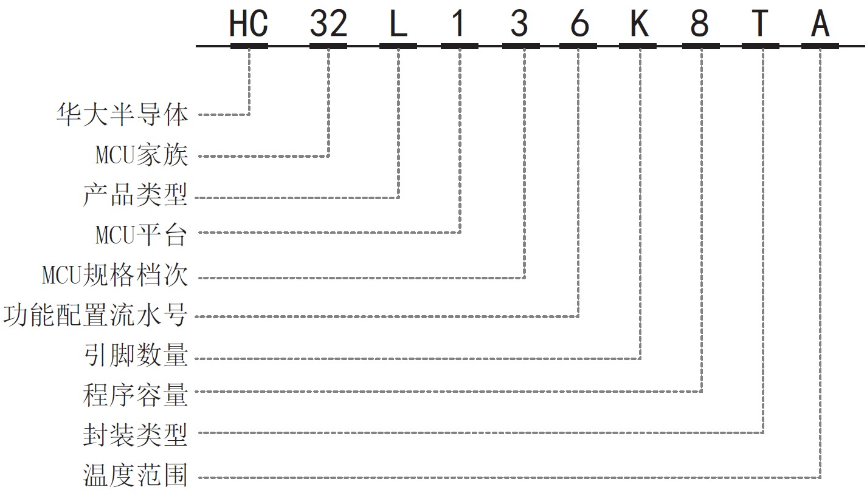

功能

|  |  |  |  |  |  |  |  |
| --- | --- | --- | --- | --- | --- | --- | --- |
| 产品名称 | | | **136K8TA** | **136J8TA** | **130J8TA** | **130F8UA** | **130E8PA** |
| 引脚数 | | | 64 | 48 | 48 | 32 | 28 |
| 通用引脚数 GPIO | | | 56 | 40 | 40 | 26 | 23 |
| CPU | | 内核 |  | Cortex M0+ | | | |
| 频率 |  | 48MHz | | | |
| 电源电压范围 | | |  | 1.8 ~5.5V | | | |
| 单/双电源 | | |  | 单电源 | | | |
| 温度范围 | | |  | -40 ~ 85℃ | | | |
| 调试功能 | | |  | 串行线调试接口 | | | |
| 唯一识别码 | | |  | 支持 | | | |
| 多功能串行接口  (UART/SPI/I2C) | | |  | UART0/1 | | | |
|  | LPUART0/1  SPI0/1 I2C0/1 | | LPUART0  SPI0 I2C0 | |
| 定时器 | | |  | Timer0/1/2/3  LPTimer  Advanced Timer4/5/6 | | | |
| 液晶控制器(LCDC) | | |  | 有 | 无 | | |
| 12 位 A/D 转换器 | | |  | 12bit | | | |
| 模拟电压比较器 | | |  | VC0/1 | | | |
| 实时时钟 | | |  | 1 | | | |
| 端口中断 | | | 56 | 40 | 40 | 26 | 23 |
| 低电压检测复位/中断 | | |  | 1 | | | |
| 时钟 | 内部高速振荡器 | |  | IRC4M/8M/16M/22.12M/24M | | | |
| 内部低速振荡器 | |  | IRC32.768K/38.4K | | | |
| 产品名称 | | | **136K8TA** | **136J8TA** | **130J8TA** | **130F8UA** | **130E8PA** |
|  | 外部高速晶振振荡器 | |  |  | 4M/8M/16M/32M |  |  |
|  | 外部低速晶振振荡器 | |  |  | 32.768kHz |  |  |
| PLL 震荡器 | |  |  | 4~48MHz |  |  |
| 蜂鸣器 |  | |  |  | Max 5ch |  |  |
| 闪存安 | 全保护 | |  |  | 支持 |  |  |
| RAM 奇偶校验 | | |  |  | 支持 |  |  |

产品选型表

|  |  |  |  |  |  |  |  |  |  |  |  |  |  |  |  |  |  |  |  |
| --- | --- | --- | --- | --- | --- | --- | --- | --- | --- | --- | --- | --- | --- | --- | --- | --- | --- | --- | --- |
| Part Number | Flash | RAM | UART | LPUART | SPI | I2C | ADC | PWM | Comp | OP | I/O | RTC | LVD | LVR | AES | LCD | Vdd | Package | 脚间距 |
| HC32L136K8TA-LQFP64 | 64K | 8K | 2 | 2 | 2 | 2 | 24*12 | 23 | 2 | 3 | 56 | v | v | v | v | 4*40 | 1.8~5.5v | LQFP64(10*10) | 0.5mm |
| HC32L136K8TA-LQ64 | 64K | 8K | 2 | 2 | 2 | 2 | 24*12 | 23 | 2 | 3 | 56 | v | v | v | v | 4*40 | 1.8~5.5v | LQFP64(7*7) | 0.4mm |
| HC32L136J8TA-LQ48 | 64K | 8K | 2 | 2 | 2 | 2 | 17*12 | 18 | 2 | 2 | 40 | v | v | v | v | 4*26 | 1.8~5.5v | LQFP48(7*7) | 0.5mm |
| HC32L130J8TA-LQ48 | 64K | 8K | 2 | 2 | 2 | 2 | 17*12 | 18 | 2 | 2 | 40 | v | v | v | v | - | 1.8~5.5v | LQFP48(7*7) | 0.5mm |
| HC32L130F8UA-QFN32TR | 64K | 8K | 2 | 1 | 1 | 2 | 8*12 | 10 | 2 | 0 | 26 | v | v | v | v | - | 1.8~5.5v | QFN32(4*4) | 0.4mm |
| HC32L130E8PA-TSSOP28 | 64K | 8K | 2 | 1 | 1 | 2 | 11*12 | 12 | 2 | 0 | 23 | v | v | v | v | - | 1.8~5.5v | TSSOP28 | 0.65mm |

# 引脚配置

HC32L136K8TA

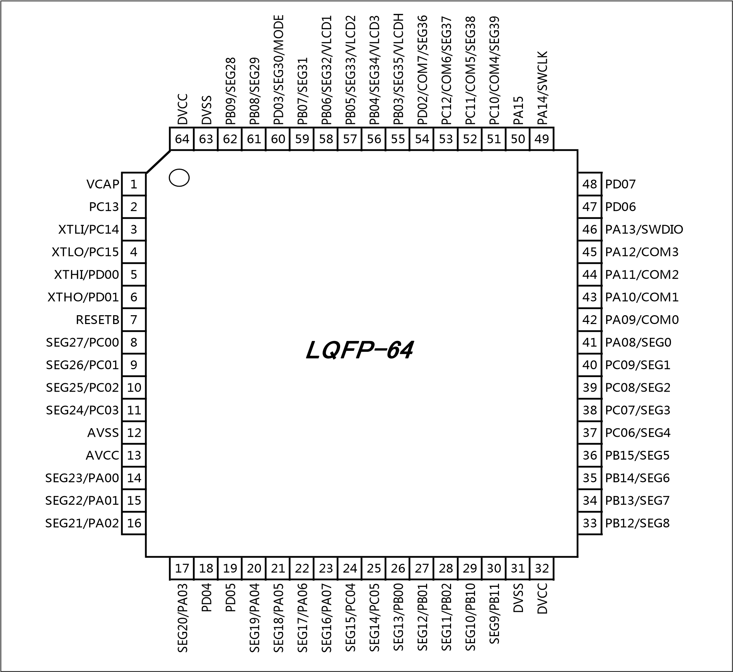

HC32L136J8TA

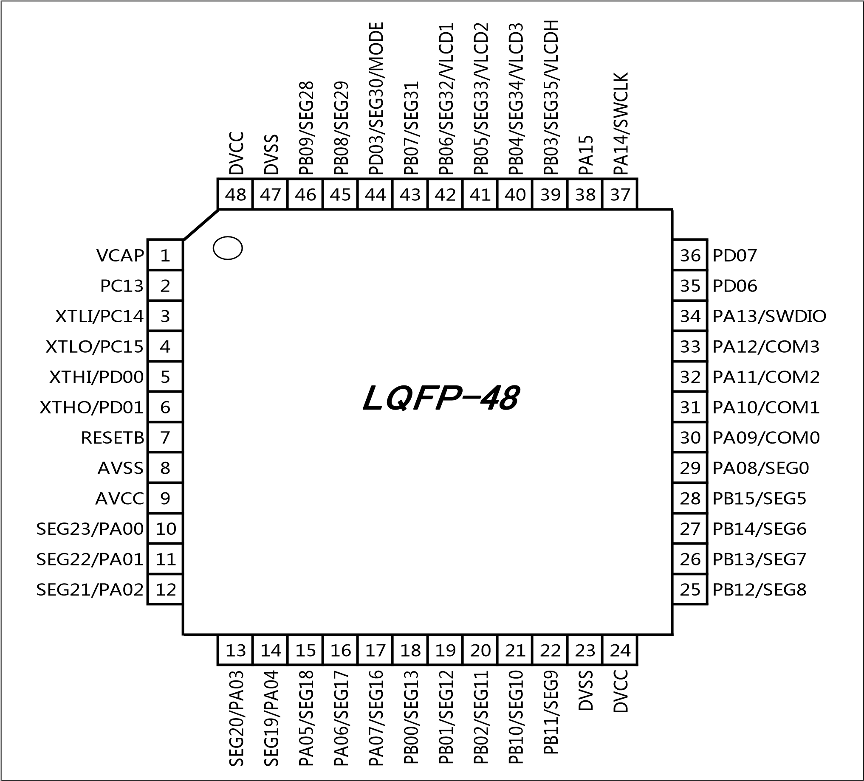

HC32L130J8TA

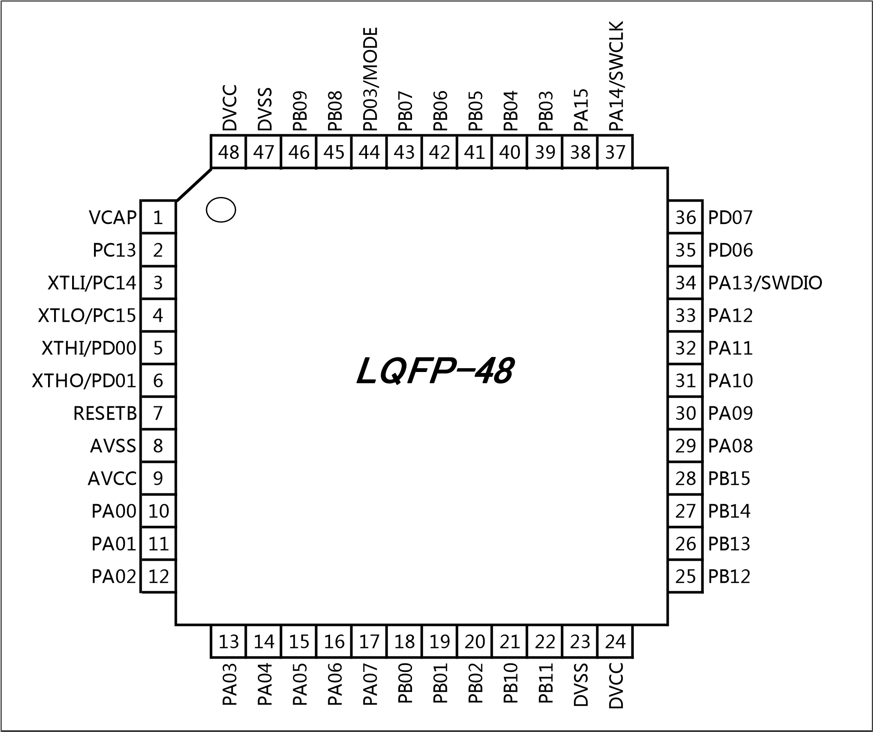

HC32L130F8UA

DVSS

PD03/MODE

PB07

PB06

PB05

PB04

PB03

PA15

32

31

30

29

28

27

26

25

VCAP

1

24

PA14/SWCLK

XTLI/PC14

2

23

PA13/SWDIO

XTLO/PC15

3

22

PA12

XTHI/PD00

4

21

PA11

XTHO/PD01

5

20

PA10

RESETB

6

19

PA09

AVCC

7

18

PA08

PA02

8

17

DVCC

9

10

11

12

13

14

15

16

PA04

PA05

PA06

PA07

PB00

PB01

PB11

DVSS

QFN

-

32

HC32L130E8PA

VCAP

1

28

PD03/MODE

XTLI/PC14

2

27

PA14/SWCLK

XTLO/PC15

3

26

PA13/SWDIO

XTHI/PD00

4

25

PA12

XTHO/PD01

5

24

PA11

RESETB

6

23

PA10

AVCC

7

22

PA09

PA00

8

21

PA08

PA01

9

20

DVCC

PA02

10

19

DVSS

PA03

11

18

PB02

PA04

12

17

PB01

PA05

13

16

PB00

PA06

14

15

PA07

TSSOP28

# 引脚功能与模块功能

引脚功能说明

|  |  |  |  |  |  |  |
| --- | --- | --- | --- | --- | --- | --- |
| **64** | **48** | **32** | **28** | **NAME** | **DIGITAL** | **ANALOG** |
| 1 | 1 | 1 | 1 | VCORE |  |  |
| 2 | 2 |  |  | PC13 | RTC_1HZ TIM3_CH1B | LVD_IN0 |
| 3 | 3 | 2 | 2 | PC14 |  | XTLI |
| 4 | 4 | 3 | 3 | PC15 |  | XTLO |
| 5 | 5 | 4 | 4 | PD00 | I2C0_SDA UART1_TXD | XTHI |
| 6 | 6 | 5 | 5 | PD01 | I2C0_SCL  TIM4_CHB  UART1_RXD | XTHO |
| 7 | 7 | 6 | 6 | RESETB |  |  |
| 8 |  |  |  | PC00 | LPTIM_GATE  PCNT_S0  UART1_CTS | AIN10  VC0_INP0  VC1_INN0  SEG27 |
| 9 |  |  |  | PC01 | LPTIM_TOG  TIM5_CHB  UART1_RTS | AIN11  VC0_INP1  VC1_INN1  SEG26 |
| 10 |  |  |  | PC02 | SPI1_MISO  LPTIM_TOGN  PCNT_S1 | AIN12  VC0_INP2  VC1_INN2  SEG25 |
| 11 |  |  |  | PC03 | SPI1_MOSI  LPTIM_ETR  LPTIM_TOGN | AIN13  VC0_INP3  VC1_INN3  SEG24 |
| 12 | 8 |  |  | AVSS |  |  |
| 13 | 9 | 7 | 7 | AVCC |  |  |

|  |  |  |  |  |  |  |
| --- | --- | --- | --- | --- | --- | --- |
| 14 | 10 |  | 8 | PA00 | UART1_CTS  LPUART1_TXD  TIM0_ETR  VC0_OUT  TIM1_CHA  TIM3_ETR  TIM0_CHA | AIN0  VC0_INP4  VC0_INN0  VC1_INP0  VC1_INN4  SEG23 |
| 15 | 11 |  | 9 | PA01 | UART1_RTS  LPUART1_RXD  TIM0_CHB  TIM1_ETR  TIM1_CHB  HCLK_OUT  SPI1_MOSI | AIN1  VC0_INP5  VC0_INN1  VC1_INP1  VC1_INN5  SEG22 |
| 16 | 12 | 8 | 10 | PA02 | UART1_TXD  TIM0_CHA  VC1_OUT  TIM1_CHA  TIM2_CHA  PCLK_OUT  SPI1_MISO | AIN2  VC0_INP6  VC0_INN2  VC1_INP2  SEG21 |
| 17 | 13 |  | 11 | PA03 | UART1_RXD  TIM0_GATE  TIM1_CHB  TIM2_CHB  SPI1_CS  TIM3_CH1A  TIM5_CHA | AIN3  VC0_INP7  VC0_INN3  VC1_INP3  SEG20 |
| 18 |  |  |  | PD04 |  |  |
| 19 |  |  |  | PD05 |  |  |
| 20 | 14 | 9 | 12 | PA04 | SPI0_CS  UART1_TXD  PCA_CH4  TIM2_ETR  TIM5_CHA  LVD_OUT  TIM3_CH2B | AIN4  VC0_INP8  VC0_INN4  VC1_INP4  SEG19 |

|  |  |  |  |  |  |  |
| --- | --- | --- | --- | --- | --- | --- |
| 21 | 15 | 10 | 13 | PA05 | SPI0_CLK  TIM0_ETR  PCA_ECI  TIM0_CHA  TIM5_CHB  XTL_OUT  XTH_OUT | AIN5  VC0_INP9  VC0_INN5  VC1_INP5  SEG18 |
| 22 | 16 | 11 | 14 | PA06 | SPI0_MISO  PCA_CH0  TIM3_BK  TIM1_CHA  VC0_OUT  TIM3_GATE  LPUART0_CTS | AIN6  VC0_INP10  VC0_INN6  SEG17 |
| 23 | 17 | 12 | 15 | PA07 | SPI0_MOSI  PCA_CH1  HCLK_OUT  TIM3_CH0B  TIM2_CHA  VC1_OUT  TIM4_CHB | AIN7  VC0_INP11  VC0_INN7  SEG16 |
| 24 |  |  |  | PC04 | LPUART0_TXD  TIM2_ETR  IR_OUT | AIN14  VC0_INN8  SEG15 |
| 25 |  |  |  | PC05 | LPUART0_RXD  TIM6_CHB  PCA_CH4 | AIN15  VC0_INN9  SEG14 |
| 26 | 18 | 13 | 16 | PB00 | PCA_CH2  TIM3_CH1B  LPUART0_TXD  TIM5_CHB  RCH_OUT  RCL_OUT  PLL_OUT | AIN8  VC0_INN10  VC1_INN6  SEG13 |
| 27 | 19 | 14 | 17 | PB01 | PCA_CH3  PCLK_OUT  TIM3_CH2B  TIM6_CHB  LPUART0_RTS | AIN9/EXVREF  VC1_INP6  VC1_INN7  SEG12 |

|  |  |  |  |  |  |  |
| --- | --- | --- | --- | --- | --- | --- |
| 28 | 20 |  | 18 | PB02 | LPTIM_TOG  PCA_ECI  LPUART1_TXD  TIM4_CHA  TIM1_BK  TIM0_BK  TIM2_BK | AIN16  VC1_INP7  VC1_INN8  OP2_INN  SEG11 |
| 29 | 21 |  |  | PB10 | I2C1_SCL  SPI1_CLK  TIM1_CHA  LPUART0_TXD  TIM3_CH1A  LPUART1_RTS  UART1_RTS | AIN17  VC1_INP8  OP2_INP  SEG10 |
| 30 | 22 | 15 |  | PB11 | I2C1_SDA  TIM1_CHB  LPUART0_RXD  TIM2_GATE  TIM6_CHA  LPUART1_CTS  UART1_CTS | AIN18  OP2_OUT  SEG9 |
| 31 | 23 | 16 | 19 | DVSS |  |  |
| 32 | 24 | 17 | 20 | DVCC |  |  |
| 33 | 25 |  |  | PB12 | SPI1_CS  TIM3_BK  LPUART0_TXD  TIM0_BK  LPUART0_RTS  TIM6_CHA | AIN19  VC1_INP9  OP1_INN  SEG8 |
| 34 | 26 |  |  | PB13 | SPI1_CLK  I2C1_SCL  TIM3_CH0B  LPUART0_CTS  TIM1_CHA  TIM1_GATE  TIM6_CHB | AIN20  VC1_INP10  OP1_INP  SEG7 |

|  |  |  |  |  |  |  |
| --- | --- | --- | --- | --- | --- | --- |
| 35 | 27 |  |  | PB14 | SPI1_MISO  I2C1_SDA  TIM3_CH1B  TIM0_CHA  RTC_1HZ  LPUART0_RTS  TIM1_BK | AIN21  VC1_INP11  OP1_OUT  SEG6 |
| 36 | 28 |  |  | PB15 | SPI1_MOSI  TIM3_CH2B  TIM0_CHB  TIM0_GATE  LPUART1_RXD | AIN22  OP0_INN  SEG5 |
| 37 |  |  |  | PC06 | PCA_CH0  TIM4_CHA  TIM2_CHA | AIN23  OP0_INP  SEG4 |
| 38 |  |  |  | PC07 | PCA_CH1  TIM5_CHA  TIM2_CHB | OP0_OUT  SEG3 |
| 39 |  |  |  | PC08 | PCA_CH2  TIM6_CHA  TIM2_ETR | SEG2 |
| 40 |  |  |  | PC09 | PCA_CH3 TIM4_CHB  TIM1_ETR | SEG1 |
| 41 | 29 | 18 | 21 | PA08 | UART0_TXD  TIM3_CH0A  TIM1_GATE  TIM4_CHA  TIM3_BK | SEG0 |
| 42 | 30 | 19 | 22 | PA09 | UART0_TXD  TIM3_CH1A  TIM0_BK  I2C0_SCL  HCLK_OUT  TIM5_CHA | COM0 |

|  |  |  |  |  |  |  |
| --- | --- | --- | --- | --- | --- | --- |
| 43 | 31 | 20 | 23 | PA10 | UART0_RXD  TIM3_CH2A  TIM2_BK  I2C0_SDA  TIM2_GATE  PCLK_OUT  TIM6_CHA | COM1 |
| 44 | 32 | 21 | 24 | PA11 | UART0_CTS  TIM3_GATE  I2C1_SCL  VC0_OUT  SPI0_MISO  TIM4_CHB | COM2 |
| 45 | 33 | 22 | 25 | PA12 | UART0_RTS  TIM3_ETR  I2C1_SDA  VC1_OUT  SPI0_MOSI  PCNT_S0 | COM3 |
| 46 | 34 | 23 | 26 | PA13 | IR_OUT  UART0_RXD  LVD_OUT  TIM3_ETR  RTC_1HZ PCNT_S1  SWDIO |  |
| 47 | 35 |  |  | PD06 | I2C1_SCL  UART3_CTS  UART0_CTS |  |
| 48 | 36 |  |  | PD07 | I2C1_SDA  UART3_RTS  UART0_RTS |  |
| 49 | 37 | 24 | 27 | PA14 | UART1_TXD  UART0_TXD  TIM3_CH2A  LVD_OUT  RCH_OUT  RCL_OUT PLL_OUT  SWCLK |  |

|  |  |  |  |  |  |  |
| --- | --- | --- | --- | --- | --- | --- |
| 50 | 38 | 25 |  | PA15 | SPI0_CS  UART1_RXD  UART3_RTS  TIM0_ETR  TIM0_CHA  TIM3_CH1A |  |
| 51 |  |  |  | PC10 | UART3_TXD  UART2_TXD  PCA_CH2 | COM4/SEG39 |
| 52 |  |  |  | PC11 | UART3_RXD  UART2_RXD  PCA_CH3 | COM5/SEG38 |
| 53 |  |  |  | PC12 | UART2_TXD  UART3_TXD  PCA_CH4 | COM6/SEG37 |
| 54 |  |  |  | PD02 | PCA_ECI  UART2_RTS  TIM1_ETR | COM7/SEG36 |
| 55 | 39 | 26 |  | PB03 | SPI0_CLK  TIM0_CHB  TIM1_GATE  TIM3_CH0A  LPTIM_GATE  XTL_OUT  XTH_OUT | VC1_INN9 SEG35/VLCDH |
| 56 | 40 | 27 |  | PB04 | SPI0_MISO  PCA_CH0  TIM2_BK  UART0_CTS  TIM2_GATE  TIM3_CH0B  LPTIM_ETR | VC0_INP12 VC1_INP12  VC1_INN10  SEG34/VLCD3 |
| 57 | 41 | 28 |  | PB05 | SPI0_MOSI  TIM1_BK  PCA_CH1  LPTIM_GATE  PCNT_S0  UART0_RTS | VC0_INP13  VC1_INP13  SEG33/VLCD2 |
| 58 | 42 | 29 |  | PB06 | I2C0_SCL  UART0_TXD  TIM1_CHB  TIM0_CHA  LPTIM_ETR  TIM3_CH0A  LPTIM_TOG | VC0_INP14  VC1_INP14  SEG32/VLCD1 |
| 59 | 43 | 30 |  | PB07 | I2C0_SDA  UART0_RXD  TIM2_CHB  UART3_CTS  TIM0_CHB  LPTIM_TOGN  PCNT_S1 | VC0_INP15  VC1_INP15  LVD_IN2  SEG31 |
| 60 | 44 | 31 | 28 | PD03 | MODE | SEG30 |
| 61 | 45 |  |  | PB08 | I2C0_SCL  TIM1_CHA  TIM2_CHA  TIM0_GATE  TIM3_CH2A  UART0_TXD | LVD_IN1  SEG29 |
| 62 | 46 |  |  | PB09 | I2C0_SDA  IR_OUT  SPI1_CS  TIM2_CHA  TIM2_CHB  UART0_RXD | SEG28 |
| 63 | 47 | 32 |  | DVSS |  |  |
| 64 | 48 |  |  | DVCC |  |  |

每个引脚的数字功能由 PSEL 位域进行控制，详见下表。

|  |  |  |  |  |  |  |  |
| --- | --- | --- | --- | --- | --- | --- | --- |
| PSEL | 1 | 2 | 3 | 4 | 5 | 6 | 7 |
| PA00 | UART1_CTS | LPUART1_TXD | TIM0_ETR | VC0_OUT | TIM1_CHA | TIM3_ETR | TIM0_CHA |
| PA01 | UART1_RTS | LPUART1_RXD | TIM0_CHB | TIM1_ETR | TIM1_CHB | HCLK_OUT | SPI1_MOSI |
| PA02 | UART1_TXD | TIM0_CHA | VC1_OUT | TIM1_CHA | TIM2_CHA | PCLK_OUT | SPI1_MISO |
| PA03 | UART1_RXD | TIM0_GATE | TIM1_CHB | TIM2_CHB | SPI1_CS | TIM3_CH1A | TIM5_CHA |
| PA04 | SPI0_CS | UART1_TXD | PCA_CH4 | TIM2_ETR | TIM5_CHA | LVD_OUT | TIM3_CH2B |
| PA05 | SPI0_SCK | TIM0_ETR | PCA_ECI | TIM0_CHA | TIM5_CHB | XTL_OUT | XTH_OUT |
| PA06 | SPI0_MISO | PCA_CH0 | TIM3_BK | TIM1_CHA | VC0_OUT | TIM3_GATE | LPUART0_CTS |
| PA07 | SPI0_MOSI | PCA_CH1 | HCLK_OUT | TIM3_CH0B | TIM2_CHA | VC1_OUT | TIM4_CHB |
| PA08 | UART0_TXD | TIM3_CH0A |  |  | TIM1_GATE | TIM4_CHA | TIM3_BK |
| PA09 | UART0_TXD | TIM3_CH1A | TIM0_BK | I2C0_SCL |  | HCLK_OUT | TIM5_CHA |
| PA10 | UART0_RXD | TIM3_CH2A | TIM2_BK | I2C0_SDA | TIM2_GATE | PCLK_OUT | TIM6_CHA |
| PA11 | UART0_CTS | TIM3_GATE | I2C1_SCL |  | VC0_OUT | SPI0_MISO | TIM4_CHB |
| PA12 | UART0_RTS | TIM3_ETR | I2C1_SDA |  | VC1_OUT | SPI0_MOSI | PCNT_S0 |
| PA13 | IR_OUT | UART0_RXD | LVD_OUT | TIM3_ETR | RTC_1HZ | PCNT_S1 |  |
| PA14 | UART1_TXD | UART0_TXD | TIM3_CH2A | LVD_OUT | RCH_OUT | RCL_OUT | PLL_OUT |
| PA15 | SPI0_CS | UART1_RXD | LPUART1_RTS | TIM0_ETR | TIM0_CHA | TIM3_CH1A |  |
| PB00 | PCA_CH2 | TIM3_CH1B | LPUART0_TXD | TIM5_CHB | RCH_OUT | RCL_OUT | PLL_OUT |
| PB01 | PCA_CH3 | PCLK_OUT | TIM3_CH2B | TIM6_CHB | LPUART0_RTS |  |  |
| PB02 | LPTIM_TOG | PCA_ECI | LPUART1_TXD | TIM4_CHA | TIM1_BK | TIM0_BK | TIM2_BK |
| PB03 | SPI0_SCK | TIM0_CHB | TIM1_GATE | TIM3_CH0A | LPTIM_GATE | XTL_OUT | XTH_OUT |
| PB04 | SPI0_MISO | PCA_CH0 | TIM2_BK | UART0_CTS | TIM2_GATE | TIM3_CH0B | LPTIM_ETR |
| PB05 | SPI0_MOSI |  | TIM1_BK | PCA_CH1 | LPTIM_GATE | PCNT_S0 | UART0_RTS |
| PB06 | I2C0_SCL | UART0_TXD | TIM1_CHB | TIM0_CHA | LPTIM_ETR | TIM3_CH0A | LPTIM_TOG |
| PB07 | I2C0_SDA | UART0_RXD | TIM2_CHB | LPUART1_CTS | TIM0_CHB | LPTIM_TOGN | PCNT_S1 |
| PB08 | I2C0_SCL | TIM1_CHA |  | TIM2_CHA | TIM0_GATE | TIM3_CH2A | UART0_TXD |
| PB09 | I2C0_SDA | IR_OUT | SPI1_CS | TIM2_CHA |  | TIM2_CHB | UART0_RXD |
| PB10 | I2C1_SCL | SPI1_SCK | TIM1_CHA | LPUART0_TXD | TIM3_CH1A | LPUART1_RTS | UART1_RTS |
| PB11 | I2C1_SDA | TIM1_CHB | LPUART0_RXD | TIM2_GATE | TIM6_CHA | LPUART1_CTS | UART1_CTS |
| PB12 | SPI1_CS | TIM3_BK | LPUART0_TXD | TIM0_BK |  | LPUART0_RTS | TIM6_CHA |
| PB13 | SPI1_SCK | I2C1_SCL | TIM3_CH0B | LPUART0_CTS | TIM1_CHA | TIM1_GATE | TIM6_CHB |
| PB14 | SPI1_MISO | I2C1_SDA | TIM3_CH1B | TIM0_CHA | RTC_1HZ | LPUART0_RTS | TIM1_BK |
| PB15 | SPI1_MOSI | TIM3_CH2B | TIM0_CHB | TIM0_GATE |  |  | LPUART1_RXD |
| PC00 | LPTIM_GATE | PCNT_S0 | UART1_CTS |  |  |  |  |
| PC01 | LPTIM_TOG | TIM5_CHB | UART1_RTS |  |  |  |  |
| PC02 | SPI1_MISO | LPTIM_TOGN | PCNT_S1 |  |  |  |  |
| PC03 | SPI1_MOSI | LPTIM_ETR | LPTIM_TOGN |  |  |  |  |
| PC04 | LPUART0_TXD | TIM2_ETR | IR_OUT |  |  |  |  |
| PC05 | LPUART0_RXD | TIM6_CHB | PCA_CH4 |  |  |  |  |
| PC06 | PCA_CH0 | TIM4_CHA | TIM2_CHA |  |  |  |  |
| PC07 | PCA_CH1 | TIM5_CHA | TIM2_CHB |  |  |  |  |
| PC08 | PCA_CH2 | TIM6_CHA | TIM2_ETR |  |  |  |  |
| PC09 | PCA_CH3 | TIM4_CHB | TIM1_ETR |  |  |  |  |
| PC10 | LPUART1_TXD | LPUART0_TXD | PCA_CH2 |  |  |  |  |
| PC11 | LPUART1_RXD | LPUART0_RXD | PCA_CH3 |  |  |  |  |
| PC12 | LPUART0_TXD | LPUART1_TXD | PCA_CH4 |  |  |  |  |
| PC13 |  | RTC_1HZ | TIM3_CH1B |  |  |  |  |
| PC14 |  |  |  |  |  |  |  |
| PC15 |  |  |  |  |  |  |  |
| PD00 | I2C0_SDA |  | UART1_TXD |  |  |  |  |
| PD01 | I2C0_SCL | TIM4_CHB | UART1_RXD |  |  |  |  |
| PD02 | PCA_ECI | LPUART0_RTS | TIM1_ETR |  |  |  |  |
| PD03 |  |  |  |  |  |  |  |
| PD04 |  |  |  |  |  |  |  |
| PD05 |  |  |  |  |  |  |  |
| PD06 | I2C1_SCL | LPUART1_CTS | UART0_CTS |  |  |  |  |
| PD07 | I2C1_SDA | LPUART1_RTS | UART0_RTS |  |  |  |  |

模块信号说明

|  |  |  |
| --- | --- | --- |
| 模块 | 引脚名称 | 描述 |
| 电源 | DVCC | 数字电源 |
| AVCC | 模拟电压 |
| DVSS | 数字地 |
| AVSS | 模拟地 |
| VCAP | LDO内核供电输出（仅限内部电路使用，需外接不小于1uF的去耦电容） |
| ISP | MODE | MODE (PD03)为高电平进入在线编程模式，通过上位机可以进行在线编程。  MODE (PD03)为低电平为工作模式 |
| ADC | AIN0~AIN23 | ADC 输入通道0~23 |
| ADC_VREF | ADC外部参考电压 |
| 电压比较VC | VCIN0~VCIN15 | VC 输入0~15 |
| VC0_OUT | VC0比较输出 |
| VC1_OUT | VC1比较输出 |
| LVD | LVDIN0 | 电压侦测输入0 |
| LVDIN1 | 电压侦测输入1 |
| LVDIN2 | 电压侦测输入2 |
| LVD_OUT | 电压侦测输出 |
| OPA  x=0,1,2 | OPx_INN | OPA负端输入 |
| OPx_INP | OPA正端输入 |
| OPx_OUT | OPA输出 |
| LCD x=0~7 y=0-39 z=1,2,3,H | COMx | LCD 公共端输出 |
| SEGy  VLCDz | LCD区段端输出  外部电阻模式，外部电容模式使用管脚 |
| UART  x=0,1 | UARTx_TXD | UARTx数据发送端 |
| UARTx_RXD | UARTx数据接收端 |
| UARTx_CTS | UARTx CTS |
| UARTx_RTS | UARTx RTS |
| LPUART  x=0,1 | LPUARTx_TXD | LPUART数据发送端 |
| LPUARTx_RXD | LPUART数据接收端 |
| LPUARTx_CTS | LPUART CTS |
| LPUARTx_RTS | LPUART RTS |
| SPI x=0,1 | SPIx_MISO | SPI模块主机输入从机输出数据信号 |
| SPIx_MOSI | SPI模块主机输出从机输入数据信号 |
| SPIx_SCK | SPI模块时钟信号 |
| SPIx_CS | SPI 片选 |
| I2C x=0,1 | I2Cx_SDA | I2C模块数据信号 |
| I2Cx_SCL | I2C模块时钟信号 |
| 通用定时器  TIMx  x=0,1,2 | TIMx_CHA | Timer的捕获输入比较输出A |
| TIMx_CHB | Timer的捕获输入比较输出B |
| TIMx_ETR | Timer的外部计数输入信号 |
| TIMx_GATE | Timer的门控信号 |
| 通用定时器  TIM3  y=0,1,2 | TIM3_CHyA | Timer的捕获输入比较输出A |
| TIM3_CHyB | Timer的捕获输入比较输出B |
| TIM3_ETR | Timer的外部计数输入信号 |
| TIM3_GATE | Timer的门控信号 |
| 低功耗定时器LPTIM | LPTIM_TOG | LPTimer的翻转输出信号 |
| LPTIM_TOGN | LPTimer的翻转输出反向信号 |
| LPTIM_EXT | LPTimer的外部计数输入信号 |
| LPTIM_GATE | LPTimer的门控信号 |
| 可编程计数阵列PCA | PCA_ECI | 外部时钟输入信号 |
| PCA_CH0 | 捕获输入/比较输出/PWM输出 0 |
| PCA_CH1 | 捕获输入/比较输出/PWM输出 1 |
| PCA_CH2 | 捕获输入/比较输出/PWM输出 2 |
| PCA_CH3 | 捕获输入/比较输出/PWM输出 3 |
| PCA_CH4 | 捕获输入/比较输出/PWM输出 4 |
| PCNT | PCNT_S0 | PCNT 脉冲计数输入0 |
| PCNT_S1 | PCNT 脉冲计数输入1 |
| 高级定时器  Advanced  Timer | TIM4_CHA | Advanced Timer4 比较输出/捕获输入端A |
| TIM4_CHB | Advanced Timer4 比较输出/捕获输入端B |
| TIM5_CHA | Advanced Timer5 比较输出/捕获输入端A |
| TIM5_CHB | Advanced Timer5 比较输出/捕获输入端B |
| TIM6_CHA | Advanced Timer6 比较输出/捕获输入端A |
| TIM6_CHB | Advanced Timer6 比较输出/捕获输入端B |

注意：

– IO 端口复位为输入高阻状态，休眠模式和深度休眠模式保持之前的端口状态。

# 框图

功能模块

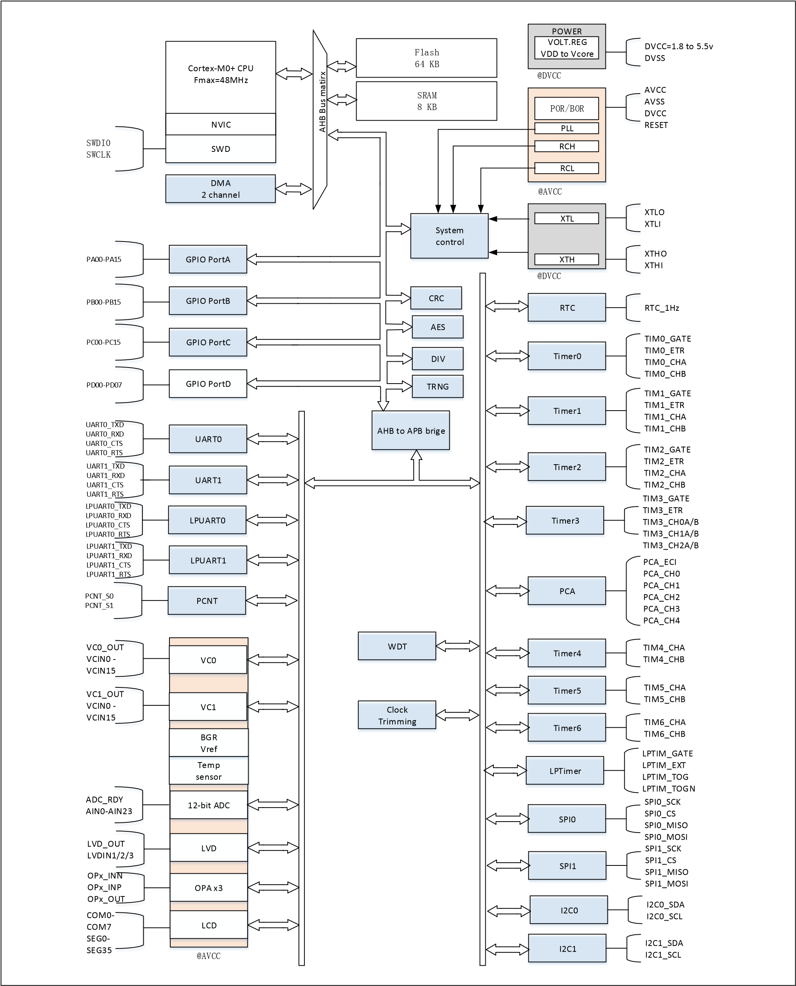

图 5-1 功能模块

# 存储区映射图

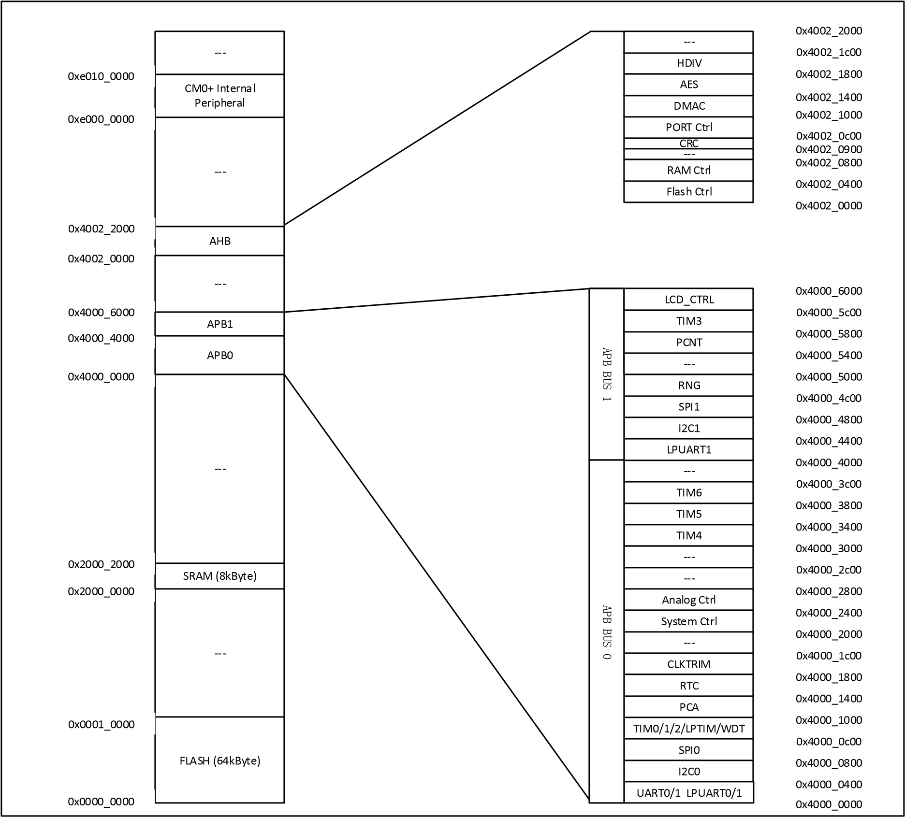

|  |  |  |  |  |
| --- | --- | --- | --- | --- |
| **HC32L136K8TA**  **HC32L136J8TA**  **HC32L130J8TA**  **HC32L130F8UA HC32L130E8PA** | | | | |
| 0x2000_2000 | | 保留 |  |  |
|  | 0x2000_0000 | SRAM （8KByte) |  |
| 0x0001_0000 | 保留 |  |
| 0x0000_0000 | 主闪存区  (64KByte) |  |
|  |

# 电气特性

## 测试条件

除非特别说明，所有电压的都以 VSS 为基准。

### 最小和最大数值

除非特别说明，在生产线上通过对 100%的产品在环境温度 TA=25°C 和 TA=TAmax 下执行的测试

(TAmax 与选定的温度范围匹配)，所有最小和最大值将在最坏的环境温度、供电电压和时钟频率条件下得到保证。

在每个表格下方的注解中说明为通过综合评估、设计模拟和/或工艺特性得到的数据，不会在生产线上进行测试；在综合评估的基础上，最小和最大数值是通过样本测试后，取其平均值再加减三倍的标准分布(平均±3Σ)得到。

### 典型数值

除非特别说明，典型数据是基于 TA=25°C 和 VCC=3.3V(1.8V ≤ VCC ≤ 5.5V 电压范围)。这些数据仅用于设计指导而未经测试。

典型的 ADC 精度数值是通过对一个标准的批次采样，在所有温度范围下测试得到，95%产品的误差小于等于给出的数值(平均±2Σ)。

### 供电方案

Regulator

Digital

logic

GPIO

VCAP

DVCC x

2

GPIOs

DVSS x

2

AVCC

AVSS

Analog

1

uF

+

10

nF

0

.

1

uFx

2

+

4

.

7

uF

0

.

1

uF

+

4

.

7

uF

注意：

– 每组电源都需要一个去耦电容，去耦电容尽量靠近相应电源管脚。

## 绝对最大额定值

加在器件上的载荷如果超过“绝对最大额定值”列表中给出的值，可能会导致器件永久性地损坏。这里只是给出能承受的最大载荷，并不意味在此条件下器件的功能性操作无误。器件长期工作在最大值条件下会影响器件的可靠性。

|  |  |  |  |  |
| --- | --- | --- | --- | --- |
| 符号 | 描述 | 最小值 | 最大值 | 单位 |
| VCC - VSS | 外部主供电电压(包含AVCC和DVCC)(1) | -0.3 | 5.5 | V |
| VIN | 在其它引脚上的输入电压(2) | VSS-0.3 | VCC + 0.3 | V |
| | ΔVCCx | | 不同供电引脚之间的电压差 |  | 50 | mV |
| | VSSx - VSS | | 不同接地引脚之间的电压差 |  | 50 | mV |
| VESD(HBM) | ESD静电放电电压(人体模型) | 参考绝对最大值电气参数 | | V |

表 7-1 电压特性

1． 所有的电源(DVCC,AVCC)和地(DVSS, AVSS)引脚必须始终连接到外部允许范围内的供电系统上。

2． IINJ(PIN)绝对不可以超过它的极限，即保证 VIN 不超过其最大值。如果不能保证 VIN 不超过其最大值，也要

保证在外部限制 I INJ(PIN)不超过其最大值。当 VIN>VCC 时，有一个正向注入电流；当 VIN<VSS 时，有一个反向注入电流。

|  |  |  |  |
| --- | --- | --- | --- |
| 符号 | 描述 | 最大值(1) | 单位 |
| IVCC | 经过DVCC/AVCC电源线的总电流(供应电流) (1) | 300 | mA |
| IVSS | 经过VSS地线的总电流(流出电流) (1) | 300 | mA |
| IIO | 任意I/O和控制引脚上的输出灌电流 | 25 | mA |
| 任意I/O和控制引脚上的输出电流 | -25 | mA |
| (2) (3)  IINJ(PIN) | RESETB引脚的注入电流 | +/-5 | mA |
| XTH的XTHI引脚和XTL的XTLI引脚的注入电流 | +/-5 | mA |
| 其他引脚的注入电流(4) | +/-5 | mA |
| (2)  ∑IINJ(PIN) | 所有I/O和控制引脚上的总注入电流(4 | +/-25 | mA |

表 7-2 电流特性

1． 所有的电源(DVCC,AVCC)和地(DVSS,AVSS)引脚必须始终连接到外部允许范围内的供电系统上。

2． IINJ(PIN)绝对不可以超过它的极限，即保证 VIN 不超过其最大值。如果不能保证 VIN 不超过其最大值，也要保证在外

部限制 I INJ(PIN)不超过其最大值。当 VIN>VCC 时，有一个正向注入电流；当 VIN<VSS 时，有一个反向注入电流。

3． 反向注入电流会干扰器件的模拟性能。

4． 当几个 I/O 口同时有注入电流时，∑I INJ(PIN)的最大值为正向注入电流与反向注入电流的即时绝对值之和。该结果基

于在器件 4 个 I/O 端口上∑IINJ(PIN)最大值的特性。

|  |  |  |  |  |
| --- | --- | --- | --- | --- |
| 符号 |  | 描述 | 数值 | 单位 |
| TSTG | 储存温度范围 |  | -60 ~ + 150 | ℃ |
| TJ | 最大结温度 |  | 105 | ℃ |

表 7-3 温度特性

## 工作条件

### 通用工作条件

|  |  |  |  |  |  |
| --- | --- | --- | --- | --- | --- |
| 符号 | 参数 | 条件 | 最小值 | 最大值 | 单位 |
| fHCLK | 内部AHB时钟频率 |  | 0 | 48 | MHz |
| fPCLK0 | 内部APB0时钟频率 |  | 0 | 48 | MHz |
| fPCLK1 | 内部APB1时钟频率 |  | 0 | 48 | MHz |
| DVCC | 标准工作电压 |  | 1.8 | 5.5 | V |
| AVCC(1) | 模拟部分工作电压 | 必须与DVCC(2)相同 | 1.8 | 5.5 | V |
| PD | 功率耗散 TA=85℃ | LQFP64 |  | 455 | mW |
| 功率耗散 TA=85℃ | LQFP48 |  | 364 | mW |
| 功率耗散 TA=85℃ | LQFP32 |  | 357 | mW |
| 功率耗散 TA=85℃ | TSSOP28 |  | 283 | mW |
| TA | 环境温度 | 最大功率消耗 | -40 | 85 | ℃ |
| 低功率消耗(3) | -40 | 105 | ℃ |
| TJ | 结温度范围 |  | -40 | 105 | ℃ |

表 7-4 通用工作条件

1． 当使用 ADC 时，参见 ADC 电气参数。

2． 建议使用相同的电源为 DVCC 和 AVCC 供电，在上电和正常操作期间，DVCC 和 AVCC 之间最多允许有 300mV

的差别。

3． 在较低的功率耗散的状态下，只要 TJ 不超过 TJmax，TA 可以扩展到这个范围。

### 上电和掉电时的工作条件

|  |  |  |  |  |  |
| --- | --- | --- | --- | --- | --- |
| 符号 | 参数 | 条件 | 最小值 | 最大值 | 单位 |
| tVcc | VCC上升速率 |  | 0 | ∞ | μs/V |
| tVcc | VCC下降速率 |  | 10 | ∞ | μs/V |

表 7-5 上电和掉电的工作条件

### 内嵌复位和 LVD 模块特性

VBOR

_

hys

+

VBOR

_

hys

-

unknown

unknown

1

.

65

V

1

.

50

v

BOR

_

5

V

VCC

Vth

~

0

.

8

v

1

．

设计保证，不在生产中测试

。

图 7-1 POR/Brown Out 示意图

|  |  |  |  |  |  |  |
| --- | --- | --- | --- | --- | --- | --- |
| Symbol | Parameter | Conditions | Min | Typ | Max | Unit |
| Vpor | POR 释放电压（上电过程） BOR 检测电压（掉电过程） |  | 1.45 | 1.50 | 1.65 | V |

表 7-6 POR/Brown Out

|  |  |  |  |  |  |  |
| --- | --- | --- | --- | --- | --- | --- |
| 符号 | 参数 | 条件 | 最小值 | 典型值 | 最大值 | 单位 |
| Vex | 外部输入电压范围 |  | 0 |  | VCC | V |
| Vlevel | 检测阈值 | LVD_CR.VTDS=0000  LVD_CR.VTDS =0001  LVD_CR.VTDS =0010  LVD_CR.VTDS =0011  LVD_CR.VTDS =0100  LVD_CR.VTDS=0101  LVD_CR.VTDS=0110  LVD_CR.VTDS=0111  LVD_CR.VTDS=1000  LVD_CR.VTDS=1001  LVD_CR.VTDS=1010  LVD_CR.VTDS=1011  LVD_CR.VTDS=1100  LVD_CR.VTDS=1101  LVD_CR.VTDS=1110  LVD_CR.VTDS=1111 | 1.7  1.8  1.9  2.0  2.1  2.2  2.3  2.4  2.5  2.6  2.7  2.8  2.9  3.0  3.1  3.2 | 1.8  1.9  2.0  2.1  2.2  2.3  2.4  2.5  2.6  2.7  2.8  2.9  3.0  3.1  3.2  3.3 | 1.9  2.0  2.1  2.2  2.3  2.4  2.5  2.6  2.7  2.8  2.9  3.0  3.1  3.2  3.3  3.4 | V |
| Icomp | 功耗 |  |  | 0.12 |  | uA |
| Tresponse | 响应时间 |  |  | 80 |  | uS |
| Tsetup | 建立时间 |  |  | 400 |  | uS |
| Vhyste | 迟滞电压 |  |  | 40 |  | mV |
| Tfilter | 滤波时间 | LVD_debounce = 000  LVD_debounce = 001  LVD_debounce = 010  LVD_debounce = 011  LVD_debounce = 100  LVD_debounce = 101  LVD_debounce = 110  LVD_debounce = 111 |  | 7  14  28  112  450  1800  7200  28800 |  | uS |

表 7-6 LVD 模块特性

### 内置的参考电压

|  |  |  |  |  |  |  |
| --- | --- | --- | --- | --- | --- | --- |
| 符号 | 参数 | 条件 | 最小值 | 典型值 | 最大值 | 单位 |
| VREF25 | Internal 2.5v Reference Voltage | 常温25°C 3.3V | 2.475 | 2.5 | 2.525 | V |
| VREF25 | Internal 2.5v Reference Voltage | -40C~85C; 2.8V~5.5V | 2.463 | 2.5 | 2.525 | V[1] |
| VREF15 | Internal 1.5v Reference Voltage | 常温25°C 3.3V | 1.485 | 1.5 | 1.515 | V |
| VREF15 | Internal 1.5v Reference Voltage | -40C~85C; 1.8V~5.5V | 1.477 | 1.5 | 1.519 | V[1] |
| TCoeff | Internal 2.5v 1.5v temperature coefficient | -40 ~ 85°C |  |  | 120 | Ppm/°  C |

1． 数据基于考核结果，不在生产中测试

### 供电电流特性

电流消耗是多种参数和因素的综合指标，这些参数和因素包括工作电压、环境温度、I/O 引脚的负载、产品的软件配置、工作频率、I/O 脚的翻转速率、程序在存储器中的位置以及执行的代码等。

微控制器处于下列条件：

* 所有的 I/O 引脚都处于输入模式，并连接到一个静态电平上——VCC 或 VSS(无负载)。
* 所有的外设都处于关闭状态，除非特别说明。
* 闪存存储器的访问时间调整到 fHCLK 的频率(0~24MHz 时为 0 个等待周期，24~48MHz 时为 1 个

等待周期)。

* 当开启外设时：fPCLK0 = fHCLK，fPCLK1 = fHCLK。

|  |  |  |  |  |  |  |  |
| --- | --- | --- | --- | --- | --- | --- | --- |
| Symbol | Parameter |  | Conditions |  | Typ(1) | Max(2) | Unit |
| IDD  (Run in  RAM) | All peripherals clock  ON,  Run while(1) in RAM | Vcore=1.5V  VCC=3.3V  TA=2xC | RCH  clock source | 4M | 655 |  | uA |
| 8M | 1290 |  |
| 16M | 2470 |  |
| 22.12M | 3500 |  |
| 24M | 3790 |  |
| PLL RCH4M to xxM  clock source | 32M | 5090 |  |
| 48M | 7580 |  |
| All peripherals clock  OFF,  Run while(1) in RAM | Vcore=1.5V  VCC=3.3V  TA=2xC | RCH  clock source | 4M | 270 |  | uA |
| 8M | 510 |  |
| 16M | 950 |  |
| 22.12M | 1320 |  |

|  |  |  |  |  |  |  |  |
| --- | --- | --- | --- | --- | --- | --- | --- |
|  |  |  |  | 24M | 1420 |  |  |
| PLL RCH4M to xxM  clock source | 32M | 1980 |  |
| 48M | 2920 |  |
| IDD  (Run  CoreMark) | All peripherals clock  OFF,  Run CoreMark in Flash | Vcore=1.5V  VCC=3.3V  TA=2xC | RCH  clock source | 4M | 735 |  | uA |
| 8M | 1415 |  |
| 16M | 2643 |  |
| 22.12M | 3573 |  |
| 24M | 3808 |  |
| PLL RCH4M to xxM | 48M FlashWait=1 | 5815 |  |
| IDD  (Run mode) | All peripherals clock  ON,  Run while(1) in Flash | Vcore=1.5V  VCC=1.8-5.5V  TA=N40C-85C | RCH  clock source | 4M | 1000 | 1300 | uA |
| 8M | 1910 | 2420 |
| 16M | 3650 | 4590 |
| 22.12M | 5080 | 6330 |
| 24M | 5440 | 6820 |
| Vcore=1.5V  VCC=1.8-5.5V  TA=N40C-85C | PLL RCH4M to xxM  clock source | 16M | 3960 | 4850 | uA |
| 24M | 5700 | 7000 |
| 32M FlashWait=1 | 6600 | 7480 |
| 40M FlashWait=1 | 8140 | 9190 |
| 48M FlashWait=1 | 9550 | 10860 |
| Vcore=1.5V  VCC=1.8-5.5V  TA=N40C-85C | PLL RCH8M to xxM  clock source | 16M | 4030 | 4940 | uA |
| 24M | 5780 | 7060 |
| 32M FlashWait=1 | 6670 | 7560 |
| 40M FlashWait=1 | 8240 | 9340 |
| 48M FlashWait=1 | 9630 | 10970 |
| All peripherals clock  OFF,  Run while(1) in Flash | Vcore=1.5V  VCC=1.8-5.5V  TA=N40C-85C | RCH  clock source | 4M | 610 | 875 | uA |
| 8M | 1330 | 1570 |
| 16M | 2110 | 2900 |
| 22.12M | 2860 | 3860 |
| 24M | 3060 | 4120 |
|  |  | 16M | 2360 | 3110 | uA |
|  |  |  |
|  |  |  |  | 24M | 3360 | 4330 |  |

|  |  |  |  |  |  |  |  |
| --- | --- | --- | --- | --- | --- | --- | --- |
|  |  | Vcore=1.5V  VCC=1.8-5.5V  TA=N40C-85C | PLL RCH4M to xxM  clock source | 32M FlashWait=1 | 3490 | 4010 |  |
| 40M FlashWait=1 | 4240 | 4890 |
| 48M FlashWait=1 | 4910 | 5720 |
| Vcore=1.5V  VCC=1.8-5.5V  TA=N40C-85C | PLL RCH8M to xxM  clock source | 16M | 2430 | 3190 | uA |
| 24M | 3420 | 4405 |
| 32M FlashWait=1 | 3560 | 4090 |
| 40M FlashWait=1 | 4320 | 4960 |
| 48M FlashWait=1 | 4980 | 5760 |
| IDD  (Sleep mode) | All peripherals clock ON | Vcore=1.5V  VCC=1.8-5.5V  TA=N40C-85C | RCH  clock source | 4M | 545 | 625 | uA |
| 8M | 1060 | 1200 |
| 16M | 2030 | 2290 |
| 22.12M | 2870 | 3230 |
| 24M | 3100 | 3470 |
| Vcore=1.5V  VCC=1.8-5.5V  TA=N40C-85C | PLL RCH4M to xxM  clock source | 16M | 2280 | 2560 | uA |
| 24M | 3350 | 3745 |
| 32M FlashWait=1 | 4190 | 4690 |
| 40M FlashWait=1 | 5210 | 5830 |
| 48M FlashWait=1 | 6210 | 6935 |
| Vcore=1.5V  VCC=1.8-5.5V  TA=N40C-85C | PLL RCH8M to xxM  clock source | 16M | 2340 | 2625 | uA |
| 24M | 3410 | 3810 |
| 32M FlashWait=1 | 4260 | 4760 |
| 40M FlashWait=1 | 5290 | 5900 |
| 48M FlashWait=1 | 6290 | 7020 |
| All peripherals clock  OFF | Vcore=1.5V  VCC=1.8-5.5V  TA=N40C-85C | RCH  clock source | 4M | 155 | 190 | uA |
| 8M | 280 | 338 |
| 16M | 500 | 586 |
| 22.12M | 680 | 800 |
| 24M | 735 | 855 |

|  |  |  |  |  |  |  |  |
| --- | --- | --- | --- | --- | --- | --- | --- |
|  |  | Vcore=1.5V  VCC=1.8-5.5V  TA=N40C-85C | PLL RCH4M to xxM  clock source | 16M | 715 | 820 | uA |
| 24M | 1005 | 1150 |
| 32M FlashWait=1 | 1060 | 1210 |
| 40M FlashWait=1 | 1290 | 1470 |
| 48M FlashWait=1 | 1520 | 1730 |
| Vcore=1.5V  VCC=1.8-5.5V  TA=N40C-85C | PLL RCH8M to xxM  clock source | 16M | 775 | 888 | uA |
| 24M | 1060 | 1210 |
| 32M FlashWait=1 | 1120 | 1280 |
| 40M FlashWait=1 | 1345 | 1530 |
| 48M FlashWait=1 | 1580 | 1800 |
| IDD  (LP Run) | All peripherals clock  ON,  Run while(1) in Flash | Vcore=1.5V  VCC=1.8-5.5V | XTL32K clock source  Driver=0x0 | TA=N40-25C | 10.3 | 15.5 | uA |
| TA=50C | 11 | 15.5 |
| TA=85C | 14.3 | 20 |
| TA=105C | 20.3 | 28 |
| All peripherals clock  OFF,  Run while(1) in Flash | Vcore=1.5V  VCC=1.8-5.5V | XTL32K clock source  Driver=0x0 | TA=N40-25C | 7.1 | 12 | uA |
| TA=50C | 7.7 | 12 |
| TA=85C | 11 | 16 |
| IDD  (LP Sleep) | All peripherals clock ON | Vcore=1.5V  VCC=1.8-5.5V | XTL32K clock source  Driver=0x0 | TA=N40-25C | 5.6 | 6.2 | uA |
| TA=50C | 6 | 6.8 |
| TA=85C | 9.2 | 11 |
| All peripherals clock  OFF | Vcore=1.5V  VCC=1.8-5.5V | XTL32K clock source  Driver=0x0 | TA=N40-25C | 2.4 | 2.7 | uA |
| TA=50C | 2.8 | 3.3 |
| TA=85C | 6 | 7.7 |
| LpTimer+RTC+32K clk  ON,  Other clk OFF | Vcore=1.5V  VCC=1.8-5.5V | XTL32K clock source  Driver=0x0 | TA=N40-25C | 2.5 | 2.8 | uA |
| TA=50C | 3 | 3.5 |
| TA=85C | 6.1 | 7.8 |
| IDD  (DeepSleep mode) | RTC+WDT+LPT+XTL32K  +DeepSleep | Vcore=1.5V  VCC=1.8-5.5V | XTL32K Driver=0x0 | TA=N40-25C | 930 | 1110 | nA |
| TA=50C | 1290 | 1610 |
| TA=85C | 3600 | 4700 |
| LPT+XTL32K  +DeepSleep | Vcore=1.5V  VCC=1.8-5.5V | XTL32K Driver=0x0 | TA=N40-25C | 825 | 1000 | nA |
| TA=50C | 1195 | 1500 |
| TA=85C | 3490 | 4540 |
|  |  |  | TA=N40-25C | 800 | 970 | nA |
|  | RTC+XTL32K  +DeepSleep | Vcore=1.5V  VCC=1.8-5.5V | XTL32K Driver=0x0 | TA=50C | 1165 | 1470 |  |
| TA=85C | 3460 | 4480 |
| XTL32K  +DeepSleep | Vcore=1.5V  VCC=1.8-5.5V | XTL32K Driver=0x0 | TA=N40-25C | 790 | 970 | nA |
| TA=50C | 1155 | 1450 |
| TA=85C | 3450 | 4530 |
| IRC32K  +DeepSleep | Vcore=1.5V  VCC=1.8-5.5V |  | TA=N40-25C | 745 | 888 | nA |
| TA=50C | 1110 | 1370 |
| TA=85C | 3400 | 4420 |
| WDT  +DeepSleep | Vcore=1.5V  VCC=1.8-5.5V |  | TA=N40-25C | 515 | 650 | nA |
| TA=50C | 865 | 1130 |
| TA=85C | 3130 | 4110 |
| DeepSleep | Vcore=1.5V  VCC=1.8-5.5V |  | TA=N40-25C | 420 | 550 | nA |
| TA=50C | 770 | 1020 |
| TA=85C | 3050 | 4040 |

1． 若没有其他指定条件，该 Typ 的值是在 25 °C & VCC = 3.3V 测得。

2． 若没有其他指定条件，该 Max 的值是 VCC = 1.8-5.5 & Temperature = N40 - 85 °C 范围内的最大值。

3． 数据基于考核结果，不在生产中测试

表 7-8 工作电流特性

### 从低功耗模式唤醒的时间

唤醒时间是在 RCH 振荡器的唤醒阶段测量得到。唤醒时使用的时钟源依当前的操作模式而定：

* 休眠模式：时钟源是 RCH 振荡器
* 深度休眠模式：时钟源是进入深度休眠时所使用的时钟是 RCH 振荡器

|  |  |  |  |  |  |  |
| --- | --- | --- | --- | --- | --- | --- |
| Symbol | Papameter | Conditions | Min | Typ | Max | Unit |
| Twu | 休眠模式唤醒时间 |  |  | 1.8 |  | μs |
| 深度休眠唤醒时间 | FMCLK = 4MHz |  | 9.0 |  | μs |
| FMCLK = 8MHz |  | 6.0 |  | μs |
| FMCLK = 16MHz |  | 5.0 |  | μs |
| FMCLK = 24MHz |  | 4.0 |  | μs |

1． 唤醒时间的测量是从唤醒事件开始至用户程序读取第一条指令。

### 外部时钟源特性

外部输入高速时钟

|  |  |  |  |  |  |  |
| --- | --- | --- | --- | --- | --- | --- |
| 符号 | 参数 | 条件 | 最小值 | 典型值 | 最大值 | 单位 |
| fXTH_ext | 用户外部时钟频率(1) |  | 0 | 8 | 32 | MHz |
| VXTHH | 输入引脚高电平电压 |  | 0.7VCC |  | VCC | V |
| VXTHL | 输入引脚低电平电压 |  | VSS |  | 0.3VCC | V |
| Tr(XTH) | 上升的时间(1) |  |  |  | 20 | ns |
| Tf(XTH) | 下降的时间(1) |  |  |  | 20 | ns |
| Tw(XTH) | 输入高或低的时间(1) |  | 16 |  |  | ns |
| Cin(XTH) | 输入容抗(1) |  |  | 5 |  | pF |
| Duty | 占空比 |  | 40 |  | 60 | % |
| IL | 输入漏电流 |  |  |  | ±1 | μA |

由设计保证，不在生产中测试。

外部输入低速时钟

|  |  |  |  |  |  |  |
| --- | --- | --- | --- | --- | --- | --- |
| 符号 | 参数 | 条件 | 最小值 | 典型值 | 最大值 | 单位 |
| fXTH_ext | 用户外部时钟频率(1) |  | 0 | 32.768 | 1000 | KHz |
| VXTHH | 输入引脚高电平电压 |  | 0.7VCC |  | VCC | V |
| VXTHL | 输入引脚低电平电压 |  | VSS |  | 0.3VCC | V |
| Tr(XTH) | 上升的时间(1) |  |  |  | 50 | ns |
| Tf(XTH) | 下降的时间(1) |  |  |  | 50 | ns |
| Tw(XTH) | 输入高或低的时间(1) |  | 450 |  |  | ns |
| Cin(XTH) | 输入容抗(1) |  |  | 5 |  | pF |
| Duty | 占空比 |  | 30 |  | 70 | % |
| IL | 输入漏电流 |  |  |  | ±1 | μA |

由设计保证，不在生产中测试。

高速外部时钟 **XTH**

高速外部时钟(XTH)可以使用一个 4~32MHz 的晶体/陶瓷谐振器构成的振荡器产生。本节中所给出的信息是基于使用下表中列出的典型外部元器件，通过综合特性评估得到的结果。在应用中，谐振器和负载电容必须尽可能地靠近振荡器的引脚，以减小输出失真和启动时的稳定时间。有关晶体谐振器的详细参数(频率、封装、精度等)，请咨询相应的生产厂商。

外部 XTH 晶振(1) (2)

|  |  |  |  |  |  |  |
| --- | --- | --- | --- | --- | --- | --- |
| 符号 | 参数 | 条件 | 最小值 | 典型值 | 最大值 | 单位 |
| FCLK | 振荡频率 |  | 4 |  | 32 | MHz |
| ESRCLK | 支持的晶振ESR范围 | 32M |  | 30 | 60 | Ohm |
| 4M |  | 400 | 1500 | Ohm |
| CLX(3) | 负载电容 | 两个管脚都有负载电容 | 12 |  | 24 | pF |
| Duty | 占空比 |  | 40 | 50 | 60 | % |
| Idd(4) | 电流 | 32M Xtal, CL=12pF,  ESR=30ohm |  | 600 |  | uA |
| Tstart(5) | 启动时间 | 32MHz  @ XTH_CR.Driver=1111 |  | 300 |  | us |
| 4MHz  @ XTH_CR.Driver=0011 |  | 2 |  | ms |

1． 谐振器的特性参数由晶体/陶瓷谐振器制造商给出。

2． 由综合评估得出，不在生产中测试。

3． CLX 指 XTAL 的两个管脚负载电容 CL1 和 CL2。对于 CL1 和 CL2，建议使用高质量的、为高频应用而设计瓷介电容

器，并挑选符合要求的晶体或谐振器。通常 CL1 和 CL2 具有相同参数。晶体制造商通常以 CL1 和 CL2 的串行组合给

出负载电容的参数。在选择 CL1 和 CL2 时，应该根据晶振的频率和 ESR 等参数，并且将 PCB 和 MCU 引脚的容抗

考虑在内。在晶振频率为 32M 时，CLX 需要选择小的电容值，XTH_CR.Driver 为 1110 时，可以选择 CLX 为 12pF。

4． 电流跟随频率变化而变化，测试条件：XTH_CR.Driver=1110

5． Tstart 是启动时间，是从软件使能 XTH 开始测量，直至得到稳定的 32MHz/4MHz 振荡这段时间。这个数值是在

XTH_CR.Startup=10 设置下，使用一个标准的晶体谐振器上测量得到，它可能因晶体制造商和型号的不同而变化较

大。

增益

控制

XTHI

XTHO

f

XTH

低速外部时钟 **XTL**

低速外部时钟(XTL)可以使用一个 32.768kHz 的晶体/陶瓷谐振器构成的振荡器产生。本节中所给出的信息是基于典型外部元器件，通过综合特性评估得到的结果。在应用中，谐振器和负载电容必须尽可能地靠近振荡器的引脚，以减小输出失真和启动时的稳定时间。有关晶体谐振器的详细参数(频率、封装、精度等)，请咨询相应的生产厂商。

外部 XTL 晶振(1)

|  |  |  |  |  |  |  |
| --- | --- | --- | --- | --- | --- | --- |
| 符号 | 参数 | 条件 | 最小值 | 典型值 | 最大值 | 单位 |
| FCLK | 振荡频率 |  |  | 32.768 |  | KHz |
| ESRCLK | 支持的晶振ESR范围 |  |  | 65 | 85 | kOhm |
| CLx | 负载电容 | 两个管脚都有负载电容 | 0 | 12 |  | pF |
| DCACLK | 占空比 |  | 30 | 50 | 70 | % |
| Idd(3) | 电流 | ESR= 65 kOhm  CL=12 pF |  | 350 | 1000 | nA |
| Tstart | 启动时间 | ESR=65 kOhm,  CL=12 pF,  40% - 60% duty cycle has been reached |  | 500 |  | ms |

1． 由综合评估得出，不在生产中测试。

2． CLX 指 XTAL 的两个管脚负载电容 CL1 和 CL2。对于 CL1 和 CL2，建议使用高质量的瓷介电容器，并挑选符合要求的

晶体或谐振器。通常 CL1 和 CL2 具有相同参数。晶体制造商通常以 CL1 和 CL2 的串行组合给出负载电容的参数。在

选择 CL1 和 CL2 时，应该将 PCB 和 MCU 引脚的容抗考虑在内。

3． 典型值为 XTL_CR.Driver=1001 时的功耗。选择具有较小 ESR 值的高质量振荡器(如 MSIV-TIN32.768kHz)，可以通

过减小 XTL_CR.Driver 设置值以优化电流消耗。

4． Tstart 是启动时间，是从软件使能 XTL 开始测量，直至得到稳定的 32768 振荡这段时间。这个数值是在

X**TL_CR.Driver=1001** 和 **XTL_CR.Startup=10** 设置下，使用一个标准的晶体谐振器上测量得到，它可能因晶体制造商和型号的不同而变化较大。

增益

控制

XTLI

XTLO

f

XTL

### 内部时钟源特性

内部 **RCH** 振荡器

|  |  |  |  |  |  |  |
| --- | --- | --- | --- | --- | --- | --- |
| Symbol | Papameter | Conditions | Min | Typ | Max | Unit |
| Dev | RCH振荡器精度 | User-trimmed with clock_trim for given VCC and TA conditions |  | 0.25 |  | % |
| VCC = 1.8V ~ 5.5V  TAMB = -40°C ~ 85°C | -2.5 |  | +2.5 | % |
| VCC = 1.8V ~ 5.5V  TAMB = -20°C ~ 50°C | -2.0 |  | +2.0 | % |
| FCLK | 振荡频率 |  | 4.0 | 4.0  8.0  16.0  22.12  24.0 | 24.0 | MHz |
| ICLK | 功耗 | FMCLK = 4MHz |  | 80 |  | μA |
| FMCLK = 8MHz |  | 100 |  | μA |
| FMCLK = 16MHz |  | 120 |  | μA |
| FMCLK = 24MHz |  | 140 |  | μA |
| DCCLK | 占空比(1) |  | 45 | 50 | 55 | % |

1． 由综合评估得出，不在生产中测试。

内部 **RCL** 振荡器

|  |  |  |  |  |  |  |
| --- | --- | --- | --- | --- | --- | --- |
| Symbol | Papameter | Conditions | Min | Typ | Max | Unit |
| Dev | RCH振荡器精度 | User-trimmed with clock_trim for given VCC and TA conditions |  | 0.5 |  | % |
| VCC = 1.8V ~ 5.5V | -2.5 |  | +2.5 | % |
| VCC = 1.8V ~ 5.5V | -1.5 |  | +1.5 | % |
| FCLK | 振荡频率 |  |  | 38.4  32.768 |  | KHz |
| TCLK | 启动时间 |  |  | 150 |  | uS |
| DCCLK | 占空比(1) |  | 25 | 50 | 75 | % |
| ICLK | 功耗 |  |  | 0.35 |  | μA |

1． 由综合评估得出，不在生产中测试。

### PLL 特性

|  |  |  |  |  |  |  |
| --- | --- | --- | --- | --- | --- | --- |
| 符号 | 参数 | 条件 | 最小值 | 典型值 | 最大值 | 单位 |
| Fin(1) | 输入时钟 |  | 4 | 4 | 24 | MHz |
|  | 输入时钟占空比 |  | 40 |  | 60 | % |
| Fout | 输出频率 |  | 8 | - | 48 | MHz |
| Duty(1) | 输出占空比 |  | 48% | - | 52% |  |
| Tlock(1) | 锁定时间 | 输入频率4MHz | - | 100 | 200 | us |

1． 由综合评估得出，不在生产中测试。

### 存储器特性

|  |  |  |  |  |  |  |
| --- | --- | --- | --- | --- | --- | --- |
| 符号 | 参数 | 条件 | 最小值 | 典型值 | 最大值 | 单位 |
| ECFLASH | 擦写次数 | Regulator voltage=1.5v,  TAMB = 25℃ | 100K |  |  | cycles |
| RETFLASH | 数据保存期限 | TAMB = 85℃ | 20 |  |  | Years |
| 常温 | 100 |  |  | Years |
| Tw_prog | 编程时间 |  | 6 |  | 7.5 | μs |
| Tp_erase | 页擦除时间 |  | 4 |  | 5 | ms |
| Tm_erase | 整片擦除时间 |  | 30 |  | 40 | ms |

### EFT 特性

芯片复位可以使系统恢复正常操作。

|  |  |
| --- | --- |
| 符号 | 级别**/**类型 |
| EFT to IO  (IEC61000-4-4) | 2kV Class:4 |
| EFT to Power  (IEC61000-4-4) | 4kV Class:4 |

软件建议软件的流程中必须包含程序跑飞的控制，如：

* 被破坏的程序计数器
* 意外的复位
* 关键数据被破坏(控制寄存器等)

在进行 ESD 测试时，可以把超出应用要求的电压直接施加在芯片上，当检测到意外动作的地方，软件部分需要加强以防止发生不可恢复的错。

### 绝对最大值(电气敏感性)

使用特定的测量方法，对芯片进行强度测试以决定它的电气敏感性方面的性能。

|  |  |  |  |  |  |  |
| --- | --- | --- | --- | --- | --- | --- |
| 符号 | 参数 | 条件 | 最小值 | 典型值 | 最大值 | 单位 |
| VESDHBM | ESD @ Human Body Mode |  |  | 8 |  | KV |
| VESDCDM | ESD @ Charge Device Mode |  |  | 2 |  | KV |
| VESDMM | ESD @ machine Mode |  |  | 200 | 500 | V |
| Ilatchup | Latch up current |  |  | 200 | 500 | mA |

### I/O 端口特性

输出特性——端口

|  |  |  |  |  |  |
| --- | --- | --- | --- | --- | --- |
| 符号 | 参数 | 条件 | 最小值 | 最大值 | 单位 |
| VOH | High level output voltage  Source Current | Sourcing 5 mA, VCC = 3.3 V  (see Note 1) | VCC-0.25 |  | V |
| Sourcing10 mA, VCC = 3.3 V  (see Note 2) | VCC-0.6 |  | V |
| VOL | Low level output voltage  Sink Current | Sinking 6 mA, VCC = 3.3 V  (see Note 1) |  | VSS+0.25 | V |
| Sinking 15 mA, VCC = 3.3 V  (see Note 2) |  | VSS+0.6 | V |
| VOHD | High level output voltage  Double source Current | Sourcing10 mA, VCC = 3.3 V  (see Note 1) | VCC-0.25 |  | V |
| Sourcing 20 mA, VCC = 3.3V  (see Note 2) | VCC-0.6 |  | V |
| VOLD | Low level output voltage  Double Sink Current | Sinking 10 mA, VCC = 3.3 V  (see Note 1) |  | VSS+0.25 | V |
| Sinking 20 mA, VCC = 3.3 V  (see Note 2) |  | VSS+0.6 | V |

表 7-9 端口输出特性

NOTES: 1. The maximum total current, IOH(max) and IOL(max), for all outputs combined, should not exceed 40 mA to satisfy the maximum specified voltage drop.

2. The maximum total current, IOH(max) and IOL(max), for all outputs combined, should not exceed 100 mA to satisfy the maximum specified voltage drop.

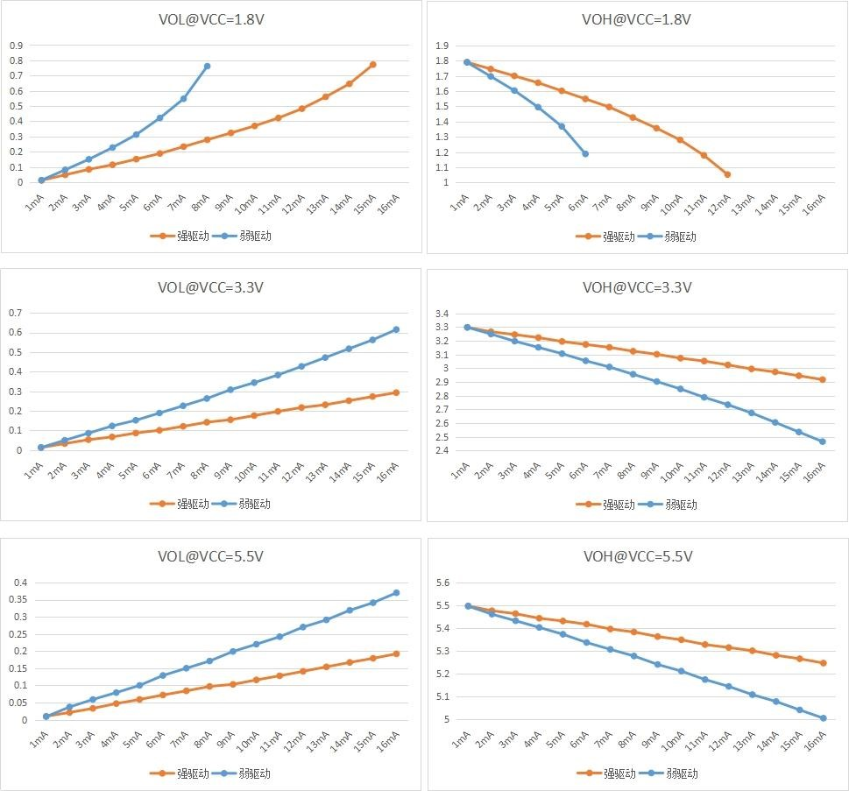

图 7-2 输出端口 VOH/VOL 实测曲线

输入特性**——**端口 **PA,PB,PC,PD, RESET**

|  |  |  |  |  |  |  |
| --- | --- | --- | --- | --- | --- | --- |
| 符号 | 参数 | 条件 | 最小值 | 典型值 | 最大值 | 单位 |
| VIH | Positive-going input threshold voltage | VCC=1.8v | 1 |  |  | V |
| VCC=3.3v | 1.75 |  |  | V |
| VCC=5.5v | 2.8 |  |  | V |
| VIL | Negative-going input threshold voltage | VCC=1.8v |  |  | 0.8 | V |
| VCC=3.3v |  |  | 1.5 | V |
| VCC=5.5v |  |  | 2.4 | V |
| Vhys(1) | Input voltage hysteresis | VCC=1.8v |  | 0.3 |  | V |
|  | (VIH - VIL) | VCC=3.3v |  | 0.4 |  | V |
| VCC=5.5v |  | 0.6 |  | V |
| Rpullhigh | Pullup resistor | Pullup enabled  VCC=3.3V |  | 80 |  | Kohm |
| Rpulllow | Pulldown resistor | Pulldown enabled  VCC=3.3V |  | 40 |  | Kohm |
| Cinput | Input capacitance |  |  | 5 |  | pf |

1． 由综合评估得出，不在生产中测试。

端口外部输入采样要求**——Timer Gate/Timer Clock**

|  |  |  |  |  |  |  |
| --- | --- | --- | --- | --- | --- | --- |
| 符号 | 参数 | 条件 | 最小值 | 典型值 | 最大值 | 单位 |
| t(int) | External interrupt timing | External trigger signal for the interrupt flag (see Note 1) | 1.8v | 30 |  | ns |
| 3.3v | 30 |  | ns |
| 5.5v | 30 |  | ns |
| t(cap) | Timer capture timing | Timer4/5/6 capture pulse width  Fsystem = 4MHz | 1.8v | 0.5 |  | us |
| 3.3v | 0.5 |  | us |
| 5.5v | 0.5 |  | us |
| t(clk) | Timer clock frequency applied to pin | Timer0/1/2/4/5/6 external clock input  Fsystem = 4MHz | 1.8v |  | PCLK/2 | MHz |
| 3.3v |  | PCLK/2 | MHz |
| 5.5v |  | PCLK/2 | MHz |
| t(pca)(2) | PCA clock frequency applied to pin | PCA external clock input  Fsystem = 4MHz | 1.8v |  | PCLK/8 | MHz |
| 3.3v |  | PCLK/8 | MHz |
| 5.5v |  | PCLK/8 | MHz |

NOTES: 1. The external signal sets the interrupt flag every time the minimum t(int) parameters are met. It may be set even with trigger

signals shorter than t(int).

2． 由综合评估得出，不在生产中测试。

端口漏电特性**——PA,PB,PC,PD**

|  |  |  |  |  |  |  |
| --- | --- | --- | --- | --- | --- | --- |
| 符号 | 参数 | 条件 | 最小值 | 典型值 | 最大值 | 单位 |
| Ilkg(Px.y) | Leakage current | V(Px.y) (see Note 1,2) |  | ±50 |  | nA |

NOTES: 1. The leakage current is measured with VSS or VCC applied to the corresponding pin(s), unless otherwise noted.

2. The port pin must be selected as input.

### RESETB 引脚特性

RESETB 引脚输入驱动使用 CMOS 工艺，它连接了一个不能断开的上拉电阻。

|  |  |  |  |  |  |  |
| --- | --- | --- | --- | --- | --- | --- |
| 符号 | 参数 | 条件 | 最小值 | 典型值 | 最大值 | 单位 |
| VIL(RESETB) (1) | 输入低电平电压 |  | -0.3 |  | 0.8 |  |
| VIH(RESETB) | 输入高电平电压 |  | 0.8*VCC |  | VCC+0.5 |  |
| Vhys(RESETB) | 施密特触发器电压迟滞 |  |  | 200 |  | mV |
| RPU | 弱上拉等效电阻 | VIN = VSS | 30 | 40 | 50 | kΩ |
| VF(RESETB)(1) | 输入滤波脉冲 |  |  |  | 100 | ns |
| VNF(RESETB) (1) | 输入非滤波脉冲 |  | 300 |  |  | ns |

1． 由设计保证，不在生产中测试。

### ADC 特性

|  |  |  |  |  |  |  |
| --- | --- | --- | --- | --- | --- | --- |
| 符号 | 参数 | 条件 | 最小值 | 典型值 | 最大值 | 单位 |
| VADCIN | Input voltage range | Single ended | 0 |  | VADCREFIN | V |
| VADCREFIN | Input range of external reference voltage | Single ended | 0 |  | AVCC | V |
| IADC1 | Active current including reference generator and buffer | 200kSPS |  | 2 |  | mA |
| IADC2 | Active current without reference generator and buffer | 1MSPS |  | 0.5 |  | mA |
| CADCIN | ADC input capacitance |  |  | 16 | 19.2 | pF |
| FADCCLK | ADC clock Frequency |  |  |  | 24M | Hz |
| TADCSTART | Startup time of reference generator and ADC core |  |  | 30 |  | μS |
| TADCCONV | Conversion time |  | 20 | 24 | 28 | cycles |
| ENOB | Effective Bits | 1MSPS@VCC>=2.7v  500KSPS@VCC>=2.4v  200KSPS@VCC>=1.8v  REF=EXREF |  | 10.3 |  | Bit |
| 1MSPS@VCC>=2.7v  500KSPS@VCC>=2.4v  200KSPS@VCC>=1.8v  REF=VCC |  | 10.3 |  | Bit |
| 200KSPS@VCC>=1.8v  REF=internal 1.5V |  | 9.4 |  | Bit |
|  |  | 200KSPS@VCC>=2.8v  REF=internal 2.5V |  | 9.4 |  | Bit |
| SNR | Signal to Noise  Ratio | 1MSPS@VCC>=2.7v  500KSPS@VCC>=2.4v  200KSPS@VCC>=1.8v  REF=EXREF |  | 68.2 |  | dB |
| 1MSPS@VCC>=2.7v  500KSPS@VCC>=2.4v  200KSPS@VCC>=1.8v  REF=VCC |  | 68.2 |  | dB |
| 200KSPS@VCC>=1.8v  REF=internal 1.5V |  | 60 |  | dB |
| 200KSPS@VCC>=2.8v  REF=internal 2.5V |  | 60 |  | dB |
| DNL(1) | Differential non-linearity | 200KSps；  VREF=EXREF/AVCC | -1 |  | 1 | LSB |
| INL(1) | Integral non-linearity | 200KSps；  VREF=EXREF/AVCC | -3 |  | 3 | LSB |
| Eo | Offset error |  |  | 0 |  | LSB |
| Eg | Gain error |  |  | 0 |  | LSB |
| MC(1) | Missing code |  | 11.999 | 12 |  | Bits |

1． 由设计保证，不在生产中测试。

### VC 特性

|  |  |  |  |  |  |  |
| --- | --- | --- | --- | --- | --- | --- |
| 符号 | 参数 | 条件 | 最小值 | 典型值 | 最大值 | 单位 |
| Vin | Input voltage range |  | 0 |  | 5.5 | V |
| Vincom | Input common mode range |  | 0 |  | VCC-0.2 | V |
| Voffset | Input offset | 常温25°C 3.3V | -10 |  | +10 | mV |
| Icomp | Comparator’s current | VCx_BIAS_SEL=00  VCx_BIAS_SEL=01  VCx_BIAS_SEL=10  VCx_BIAS_SEL=11 |  | 0.3  1.2  10  20 |  | uA |
| Tresponse | Comparator’s response time when one input cross another | VCx_BIAS_SEL=00  VCx_BIAS_SEL=01  VCx_BIAS_SEL=10  VCx_BIAS_SEL=11 |  | 20  5  1  0.2 |  | uS |
| Tsetup | Comparator’s setup time when ENABLE.  Input signals unchanged. | VCx_BIAS_SEL=00  VCx_BIAS_SEL=01  VCx_BIAS_SEL=10  VCx_BIAS_SEL=11 |  | 20  5  1  0.2 |  | uS |
| Twarmup | From main bandgap enable to 1.2V BGR reference、Temp sensor voltage、ADC internal 1.5V、2.5V reference stable |  |  | 20 |  | uS |
| Tfilter | Digital filter time | VC_debounce = 000  VC_debounce = 001  VC_debounce = 010  VC_debounce = 011  VC_debounce = 100  VC_debounce = 101  VC_debounce = 110  VC_debounce = 111 |  | 7  14  28  112  450  1800  7200  28800 |  | μS |

### OPA 特性

OPA：(AVCC=2.2V ~ 5.5 V, AVSS=0 V, Ta=- 40°C ~ +85°C)

|  |  |  |  |  |  |  |
| --- | --- | --- | --- | --- | --- | --- |
| 符号 | 参数 | 条件 | 最小值 | 典型值 | 最大值 | 单位 |
| Vi | 输入电压 |  | 0 | - | AVCC | V |
| Vo | 输出电压(1) |  | 0.1 | - | AVCC-  0.1 | V |
| Io | 输出电流(1) |  |  |  | 0.5 | mA |
| RL | 负载电阻(1) |  | 10K |  |  | Ohm |
| Tstart | 初始化时间(2) |  |  |  | 20 | us |
| Vio | 输入失调电压 | Vic=AVCC/2, Vo=AVCC/2,  RL=10KΩ, Rs=50Ω |  | ±6 |  | mV |
| PM | 相位范围(1) | RL=10kΩ, CL=20pF |  | 65 | - | deg |
| GM | 增益范围(2) | RL=10kΩ, CL=20pF |  | 15 | - | dB |
| UGBW | 单位增益带宽(1) | CL=20pF |  | 2.5 |  | MHz |
| SR | 压摆率(1) | CL=15pF |  | 2.6 |  | V/uS |
| CMRR | 共模抑制比(1) |  |  | 70 |  | dB |

1． 由设计保证，不在生产中测试。

2． 需要同时设置 BGR_CR<0>=1

### LCD 控制器

|  |  |  |  |  |  |  |
| --- | --- | --- | --- | --- | --- | --- |
| 符号 | 参数 | 工作条件 | 最小 | 典型 | 最大 | 单位 |
| ILCD | 电流 | VCC=3.3V |  | 3.3 |  | uA |
| RH | 低驱动电阻 |  |  | 1M |  | Ω |
| RL | 高驱动电阻 |  |  | 360K |  | Ω |
| VLCDH | LCD 可调最高电压 |  |  |  | VCC | V |
| VLCD3 | LCD 最高电压 |  |  |  | VLCDH | V |
| VLCD2 | LCD 2/3电压 |  |  |  | 2/3 VLCDH | V |
| VLCD1 | LCD 1/3电压 |  |  |  | 1/3 VLCDH | V |
| VLCD0 | LCD 最低电压 |  | 0 |  |  | V |
| △VXX | LCD 电压偏差 | TA=-40~85℃ |  |  | ±50 | mV |

# 封装尺寸

**LQFP64** 封装

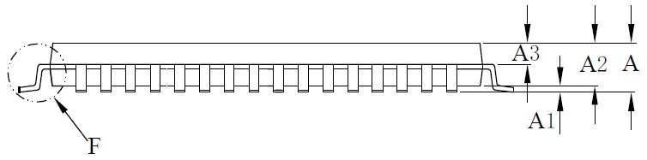

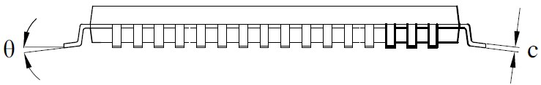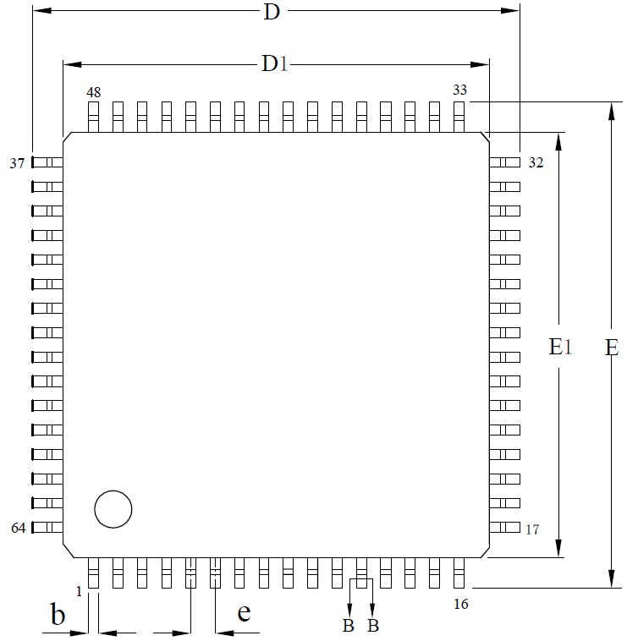

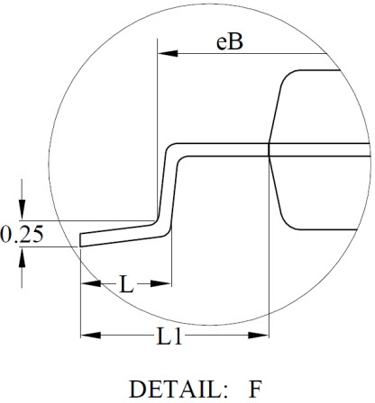 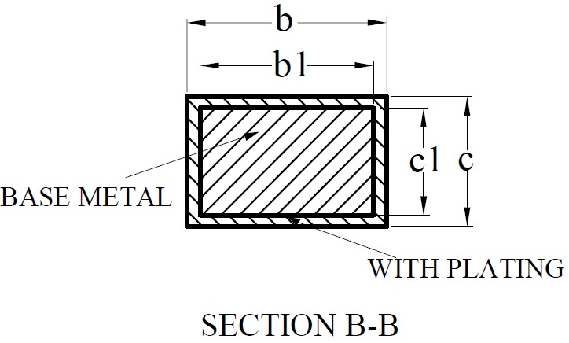

|  |  |  |  |  |  |  |
| --- | --- | --- | --- | --- | --- | --- |
| **Symbol** | **LQFP64 (10x10)** | | |  | **LQFP64 (7x7)** | |
| **Min** | **Nom** | **Max** | **Min** | **Nom** | **Max** |
| A | -- | -- | 1.60 | -- | -- | 1.60 |
| A1 | 0.05 | -- | 0.15 | 0.05 | -- | 0.15 |
| A2 | 1.35 | 1.40 | 1.45 | 1.35 | 1.40 | 1.45 |
| A3 | 0.59 | 0.64 | 0.69 | 0.59 | 0.64 | 0.69 |
| b | 0.18 | -- | 0.26 | 0.16 | -- | 0.24 |
| b1 | 0.17 | 0.20 | 0.23 | 0.15 | 0.18 | 0.21 |
| c | 0.13 | -- | 0.17 | 0.13 | -- | 0.17 |
| c1 | 0.12 | 0.13 | 0.14 | 0.12 | 0.13 | 0.14 |
| D | 11.80 | 12.00 | 12.20 | 8.80 | 9.00 | 9.20 |
| D1 | 9.90 | 10.00 | 10.10 | 6.90 | 7.00 | 7.10 |
| E | 11.80 | 12.00 | 12.20 | 8.80 | 9.00 | 9.20 |
| E1 | 9.90 | 10.00 | 10.10 | 6.90 | 7.00 | 7.10 |
| eB | 11.25 | -- | 11.45 | 8.10 | -- | 8.25 |
| e | 0.50BSC | | |  | 0.40BSC | |
| L | 0.45 | -- | 0.75 | 0.40 | -- | 0.65 |
| L1 | 1.00REF | | |  | 1.00REF | |
| θ | 0° | -- | 7° | 0° | -- | 7° |

**LQFP48** 封装

|  |  |  |  |  |  |  |  |  |  |  |  |  |  |  |  |  |  |  |  |  |  |  |  |  |  |  |  |  |  |  |  |  |  |  |  |  |  |  |  |  |  |  |  |  |  |  |  |  |  |  |  |  |  |  |  |  |  |  |  |  |  |  |  |  |  |  |  |  |  |  |  |  |  |  |  |  |
| --- | --- | --- | --- | --- | --- | --- | --- | --- | --- | --- | --- | --- | --- | --- | --- | --- | --- | --- | --- | --- | --- | --- | --- | --- | --- | --- | --- | --- | --- | --- | --- | --- | --- | --- | --- | --- | --- | --- | --- | --- | --- | --- | --- | --- | --- | --- | --- | --- | --- | --- | --- | --- | --- | --- | --- | --- | --- | --- | --- | --- | --- | --- | --- | --- | --- | --- | --- | --- | --- | --- | --- | --- | --- | --- | --- | --- |
|  | |  |  |  |  | | --- | --- | --- | --- | | **Symbol** |  | **Millimeter** |  | | **Min** | **Nom** | **Max** | | A | -- | -- | 1.60 | | A1 | 0.05 | -- | 0.15 | | A2 | 1.35 | 1.40 | 1.45 | | A3 | 0.59 | 0.64 | 0.69 | | b | 0.18 | -- | 0.26 | | b1 | 0.17 | 0.20 | 0.23 | | c | 0.13 | -- | 0.17 | | c1 | 0.12 | 0.13 | 0.14 | | D | 8.80 | 9.00 | 9.20 | | D1 | 6.90 | 7.00 | 7.10 | | E | 8.80 | 9.00 | 9.20 | | E1 | 6.90 | 7.00 | 7.10 | | eB | 8.10 | -- | 8.25 | | e |  | 0.50BSC |  | | L | 0.40 | -- | 0.65 | | L1 |  | 1.00REF |  | | θ | 0 | -- | 7° | |
|  |
|  |

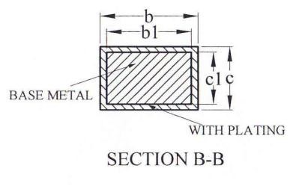

**QFN32** 封装

|  |  |  |  |  |  |  |  |  |  |  |  |  |  |  |  |  |  |  |  |  |  |  |  |  |  |  |  |  |  |  |  |  |  |  |  |  |  |  |  |  |  |  |  |  |  |  |  |  |  |  |  |  |  |  |  |  |  |  |  |  |  |  |  |  |  |  |  |  |  |  |  |  |  |  |  |  |  |  |  |  |  |  |  |
| --- | --- | --- | --- | --- | --- | --- | --- | --- | --- | --- | --- | --- | --- | --- | --- | --- | --- | --- | --- | --- | --- | --- | --- | --- | --- | --- | --- | --- | --- | --- | --- | --- | --- | --- | --- | --- | --- | --- | --- | --- | --- | --- | --- | --- | --- | --- | --- | --- | --- | --- | --- | --- | --- | --- | --- | --- | --- | --- | --- | --- | --- | --- | --- | --- | --- | --- | --- | --- | --- | --- | --- | --- | --- | --- | --- | --- | --- | --- | --- | --- | --- | --- | --- |
|  | |  |  |  |  | | --- | --- | --- | --- | | **Symbol** |  | **QFN32** |  | | **Min** | **Nom** | **Max** | | A | 0.70 | 0.75 | 0.80 | | 0.85 | 0.90 | 0.95 | | A1 | 0 | 0.02 | 0.05 | | A3 | -- | 0.20REF | -- | | b | 0.15 | 0.20 | 0.25 | | D |  | 4.0BSC |  | | E |  | 4.0BSC |  | | D2 | 2.60 | 2.70 | 2.80 | | E2 | 2.60 | 2.70 | 2.80 | | e |  | 0.40BSC |  | | L | 0.30 | 0.35 | 0.40 | | L1 | 0.27 | 0.32 | 0.37 | | K | 0.20 | -- | -- | | aaa |  | 0.10 |  | | bbb |  | 0.07 |  | | ccc |  | 0.10 |  | | ddd |  | 0.05 |  | | eee |  | 0.08 |  | | fff |  | 0.10 |  | |
|  |
|  |
|  |

|  |  |  |  |
| --- | --- | --- | --- |
| **Symbol** |  | **Millimeter** |  |
| **Min** | **Nom** | **Max** |
| A | -- | -- | 1.20 |
| A1 | 0.05 | -- | 0.15 |
| A2 | 0.80 | -- | 1.00 |
| A3 | 0.39 | 0.44 | 0.49 |
| b | 0.20 | -- | 0.29 |
| b1 | 0.19 | 0.22 | 0.25 |
| c | 0.14 | -- | 0.18 |
| c1 | 0.12 | 0.13 | 0.14 |
| D | 9.60 | 9.70 | 9.80 |
| E | 6.20 | 6.40 | 6.60 |
| E1 | 4.30 | 4.40 | 4.50 |
| e |  | 0.65BSC |  |
| L | 0.45 | 0.60 | 0.75 |
| L1 |  | 1.00BSC |  |
| θ | 0 | -- | 8° |

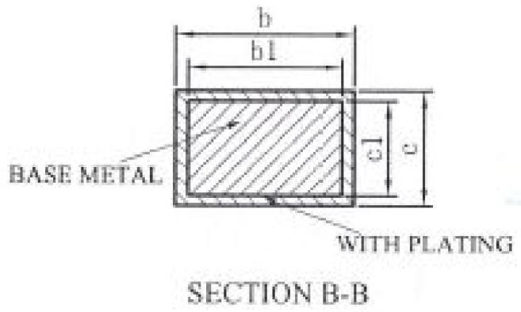**TSSOP28** 封装

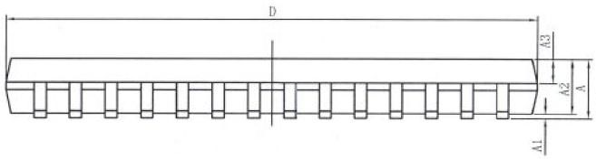

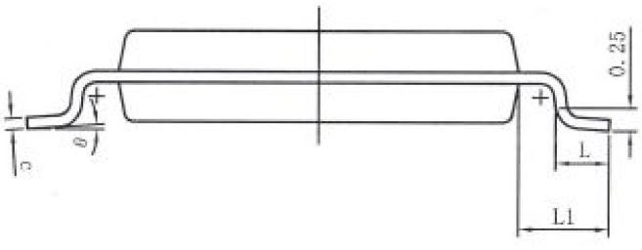

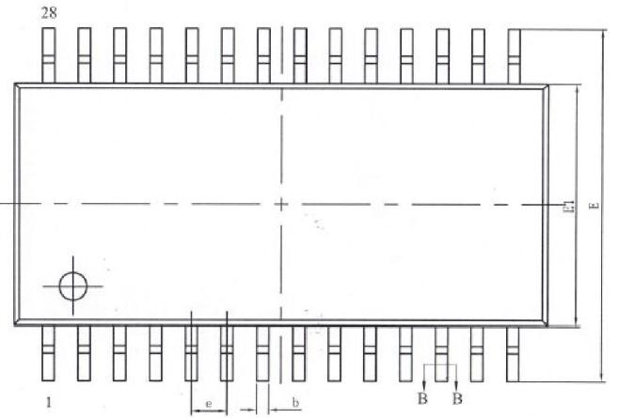

# 版本记录 **&** 联系方式

|  |  |  |
| --- | --- | --- |
| 版本 | 修订日期 | 修订内容摘要 |
| Rev1.0 | 2018/8/20 | 初版发布。 |
|  |  |  |
|  |  |  |

如果您在购买与使用

过程

中有任何

意见

或

建议，请随时与我们联系

。



Email：mcu@hdsc.com.cn 网址：[www.hdsc.com.cn](http://www.hdsc.com.cn/)

通信地址：上海市张江高科园区碧波路 572 弄 39 号

邮编

：

20

1203

